Paris, le 13 mai 2005
Etab=DG75, Timbre=F233, TimbreDansAdresse=Oui, Version=W2000-C-5.1/9.0, VersionTravail=W2000-C-5.1/9.0

DIRECTION DES STATISTIQUES DEMOGRAPHIQUES ET SOCIALES
Département de l'Emploi et des Revenus d'Activité
Division "Emploi"
Section « Professions-Qualifications-Formation »
Section "Enquêtes"

NOTE
à l'attention de David Rose, responsable du consortium ESeC
Dossier suivi par :
Pierre BISCOURP, Stéphanie DUPAYS
Tél. : 01.41.17.65.14 - 01.41.17.67.88
Fax : 01.41.17.61.63
Messagerie : pierre.biscourp@insee.fr
stephanie.dupays@insee.fr

N° 084/F233

Object : French validation plans of the European socioeconomic classification with French statistical sources

Following the Paris March meeting, the French team has started to construct and validate the European Socioeconomic Classification (ESeC).

The validation plan is based on the use of the French classification of occupations. Let us again emphasize the reasons for using the national classification of occupations (PCS, “professions et catégories socioprofessionnelles”) :

- The mapping into 3-digit ISCO can only be achieved when the 4-digit PCS as well as the 4-digit classification of economic activity are available.
- Relatively few French sources allow the coding of occupation at the 4-digit level. In most surveys describing social and cultural behavior, only the 2-digit level (CS, “catégorie socioprofessionnelle”) is available. Even in surveys where occupation of the main job is coded at the 4-digit level, father’s occupations for instance can only be coded at the 2-digit level.
- No mapping is possible from CS into ISCO, not even at the 2-digit level of ISCO.

The reason for this difficulty is that PCS and ISCO are based on fundamentally different logics. Indeed, the ESeC principles are already, at least to some extent, embedded in the PCS (especially at the 2-digit CS level).

- Using the ESeC matrix based on ISCO compels us to construct additional variables (such as “manager”, “supervisor”), using all the national information available. This adds complexity, measurement errors, and eventually comparison problems across European countries.
- Using PCS or CS is more straightforward, as the additional variables are already embedded in the classification. Besides, the national classification fits better with the employment relations in France, as it has been developed for over half a century along lines similar to ESeC.

The French national classification of occupations is therefore our starting point. Considering the amount of information available for coding occupation varies from one source to the other, we propose 2 constructions of ESeC. The first construction is based on CS only (i.e. 2-digit occupation classification). The second construction is based on PCS (i.e. 4-digit occupation classification), less frequently available yet providing a priori more detailed information on employment relations, as well as on a set of additional variables usually available in French surveys. In this note, we carry out empirical tests in order to assess the amount of relevant information lost when using the more aggregate version instead of the more detailed one.

The rest of this note is organized as follows. We first present and discuss the two constructions of ESeC based on the 4-digit and 2-digit levels of occupation. In other words, we present and discuss groupings of occupations consistent with the underlying concepts of ESeC agreed on at the Paris meeting.
We then present the data we use for our validation, the 1998 working conditions survey (“enquête sur les conditions de travail”). At first, the empirical analysis is purely statistical, and carried out independently from the a priori classifications presented in the first part of the note. In other words, we let the data talk, then compare the results to the classification derived from our own expertise.
We finally discuss whether the construction of ESeC based on PCS fits the data better than the one solely based on CS. We conclude.

1 - Two implementations of ESeC corresponding to different sets of information on occupation

Table 1 shows two different constructions of EseC (version 2.1 agreed on in Paris).

The first construction is given in the third column (“default ESeC”). It is based on the sole 2-digit occupation (CS). The groupings of CS are made consistently with the underlying concepts of ESeC. They are a priori groupings based on what we know of the employment relations prevailing in these CS. We now comment this construction.

For the employers and the self-employed, the mapping into EseC is relatively straightforward. By default, farmers are all assigned to group 5. Craft workers and small retailers with less than 10 employees are assigned to group 4. Heads of businesses are assigned to group 1. Note that heads of business are defined as employers with 10 employees or more. There are few operational problems associated with these CS.
As far as employees are concerned, there is still in France a clear-cut distinction in terms of employment relations between “cadres” (executives) and other employees. “Cadres” are either professionals (higher or lower) or managers (higher or lower). They can therefore be assigned to groups 1 or 2. If they hold positions associated with particularly high technical expertise or power of decision on the firm’s strategy, they should be assigned to group 1. They should otherwise be assigned to group 2. As the CS alone does not provide this information, all “cadres” end up by default in group 2, as higher professionals and managers are far less numerous than their counterparts of lower level.
Intermediate level CS, excluding supervisors and technicians, are assigned to group 3. Supervisors and technicians are assigned to group 7.
Group 6 consists of lower service, clerical and sales CS, except those characterized by routine tasks. Group 8 consists of all skilled technical workers. Group 9 consists of all remaining CS, characterized by predominently routine tasks.

Table 1

Additional information is used for the second implementation of EseC. It is displayed in the remaining columns. Let us give the example of CS 43 (intermediate health-care and social workers). Recall that they are assigned to group 3 when only the CS is available. However, the persons in this CS who report being classified as “cadres” are assigned to group 2 (for instance “cadres infirmiers”). Those whose self-reported occupation contains keywords such as “director”, or report being classified as a director or a close associate of the director, are also classified in group 2 (for instance, “directeur de centre social”). When the 4-digit PCS is available, the last column of the table finally provides a list of PCS codes assigned to group 2. For instance the PCS 4311 consists of the “cadres infirmiers”.

2 - Data and method

The 1998 working conditions survey is a supplement to the 1998 labor force survey. We use it to measure employment relations by occupation. In this survey, the main occupation at the date of the survey is coded in the 4-digit PCS.

Let us first describe briefly the information relevant to describe employment relations.

We have information on the status of employment : employee / self-employed or employer. For employees, the survey provides the monthly wage, as well as the type of contract: indefinite duration contracts vs. temporary contracts, as well as life employment contracts. Persons working part-time are also identified. For all persons, we have the highest degree as well as tenure in the firm. Tenure reflects the stability of the employment relation. Using the degree in the analysis is more controversial. The reason why we retain this variable is that we need some measure of “expertise” to assign occupations to EseC groups. In order to assess the impact of this variable on the implementation of EseC, we provide results where the degree is omitted.
As the working condition survey is a supplement to the LFS, we can make use of information on the employee’s situation up to 2 years before. We retain two pieces of information : whether the person was employed in the same establishment 2 years before, and if so, what was the wage growth over the period.

The working conditions variables relevant to describe employment relations are the following:

- supervisory responsibility, with or without power over the pay and career of subordinates;
- production-line work ;
- job consists in repeating the same series of operations;
- pace of work imposed by supervisors or machines or other technical constraints;
- person carries out instructions strictly ;
- instructions specify how to do the work as well as the work to do;
- person deals with incidents on their own or calls to hierarchy ;

These variables provide information on autonomy at work, as well as the routine characteristics of the job.

We also make use of information obtained from the 2000 training survey, which is a supplement to the 2000 LFS. We retain one variable: whether the person has benefited during the last 12 months from training paid by his/her employer. We think that we are capturing the fact that employers invest more in employees that enjoy a service relationship.

We compute the mean of every employment relations variable, first by CS, then by PCS. We then analyze the corresponding datasets using cluster analysis. In other words, we use all the information available to construct groupings of CS or PCS, based on the proximity of these categories in the space of wage, tenure, autonomy, degree, supervisory responsibility, routine and training variables. We use several specifications, based on different sets of information (see below, table 2).

3 - First results of the statistical analysis

We use 4 sets of variables. The first one is the complete set described above (wage, tenure, autonomy, degree, supervisory responsibility, routine and training variables). In the second set of variables we exclude wage variables. In the third one we exclude degree. In the last one we exclude supervisory responsibility. Each specification corresponds to a column in table2.

Figure 1 shows the classification tree based on the first specification. Numbers in abscissa show CS codes. The tree is read from top to bottom. The two main branches oppose employees to self-employed and employers. Among the latter, farmers constitute a specific group (11,12,13), self-employed professionals (31) stand slightly apart, whereas employers with 10 employees or more (23) differ only slightly from self-employed craft workers (21) and small retailers (22).
Among employees, the two main branches oppose higher occupations to subordinate occupations. Among the former, the “cadres” (excluding artists) are one group, and the intermediate occupations another. In a more subtle way, the public sector “cadres” (33 and 34) differ from the private firms executives (37 and 38). Among the intermediate CS, artists (35) and clergymen (44) have specific positions. The mainly public sector CS (42 and 43) differentiate themselves somewhat from the mainly non-supervisory private sector CS (46 and 47), and from the mainly supervisory CS (48, and to a lesser extent 45).
The lower-level branch among employees (left part of figure 1) opposes skilled occupations on the left to mainly unskilled ones. Within the former, clerical and service occupations (52,53,54) differ from blue-collar workers (62 to 65). Within the latter, unskilled industry workers occupy a specific position.

Figure 1
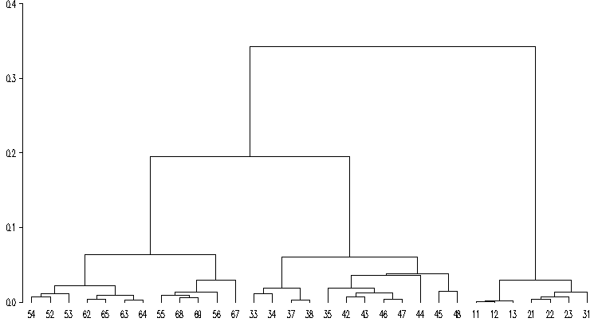

Table 2 shows the best aggregation of the French classification CS into 10 groups of homogeneous employment relations and for our four measures of employment relations.

Excluding the wage variables only has minor consequences: private sector clerks tend to join the intermediate group.
The degree variable has much more impact on the classification: skilled clerks join the group of skilled blue-collar workers, as do nurses and social educators (43). Omitting the degree therefore implies that quite heterogeneous occupations are assigned to the same group.
Finally, omitting the supervisory variable leads to aggregate private sector intermediate occupations, and leave on their own public sector intermediate occupations.

Table 2

However, the supervisory variable is an important component of employment relations, therefore has to be retained. Similarly, the wage variables cannot be omitted. Initial education is a proxy for expertise, therefore is also relevant to the classification we are building.

Let us now compare the groupings derived from the statistical analysis, based on the first set of variables, with the groupings of CS described in table 1 (default ESeC codes).
- Farmers (CS 11 to 13) are close according to the analysis, which is consistent with the default grouping in table 1 ;
- The self-employed craft workers and retailers (CS 21 and 22) are close, which is again consistent with the default grouping in table 1 ;
- However, heads of businesses with 10 employees or more (CS 23) as well as self-employed professionals (CS 31) were not expected to belong to the same group as the previous CS ; as for heads of businesses, the 10 employee threshold may not be appropriate ; as for self-employed professionals, figure 1 suggests that it still makes sense to distinguish them from the other self-employed.
- Among employees, all CS of “cadres” (CS 33 to 38) are close according to the statistical analysis as well as the a priori groups ; the only exception is the CS 35 (artists and information occupations), closer to intermediate occupations than to “cadres” ; however, the only reason to assign artists to the group 2 of ESeC is the fact that they are traditionally considered as “cadres” in the French classification of occupation ; obviously, these occupations do not lend themselves easily to classification ;

- Among intermediate CS, the clergy (CS 44) stands apart ; more significantly, foremen and supervisors (CS 48) and public sector intermediate occupations (CS 45) also stand apart ; the former were indeed assigned to a specific group of ESeC ; as for the latter, this is harder to justify and the robustness of this result must be checked ; finally, technicians are not particularly close to supervisors ; the statistical analysis might thus suggest putting them into the group 3 of ESeC rather than into group 7 ; the logics of keeping the CS 47 and 48 together can only rest on there proximity in terms of working environment ;

- Lower level skilled blue collar workers are close (CS 62 to 65) ; this was expected, even if drivers (CS 64) were a priori viewed as part of group 6 of ESeC ; this is an issue to discuss ;

- Skilled lower level employees (CS 52, 53, 54) are close, as expected from table 1; however, salespersons (CS 55) do not belong to the same group as expected ;

- Indeed, salespersons appear closer to unskilled lower level employees (CS 56,68,69), expected to belong to the group 9 of ESeC ; the classification of salespersons is therefore an issue to discuss ;

- Finally, unskilled blue-collar workers (CS 67) have specific employment relations, yet it makes sense to ignore this specificity (production-line work for instance) and keep them in the group of routine occupations (together with CS 56 to 69).

An important issue is to assess whether using additional information (such as the 4-digit PCS, as shown in table 1) allows to construct ESeC groups more consistent with data. In other words, is the CS sufficient, and how large is the loss of precision when the 4-digit PCS is not available ? To answer this question, we replicate the previous analysis using occupation categories combining the CS and the ESeC code attributed using all information, including the 4-digit PCS : for instance, according to table 1, the CS 43 is assigned either to group 3 or to group 2 when the 4-digit PCS or information on job classification is available. We thus associate 2 codes to the CS 43 : 432 and 433. If the additional information is irrelevant, then we should obtain a classification tree identical to that in figure 1.

The actual tree is shown in figure 2.

Figure 2
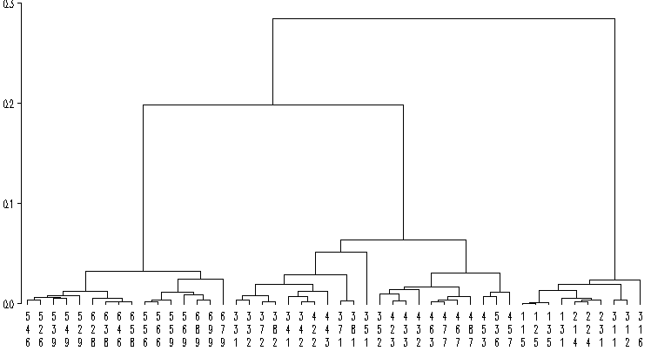

Differences with figure 1 are :

- farmers on large holdings with employees (131) are closer to self-employed craft workers, small retailers and large employers (214,224,231), than to farmers with no employees (115,125,135) ;
- artists and information professionals assigned to group 1 (351) resemble the other “cadres”, whereas artists and information professionals assigned to group 2 (352) resemble intermediate occupations more closely ;
- intermediate school teachers assigned to group 2 (422) resemble secondary-school teachers closely, while those assigned to group 3 (423) resemble intermediate occupations ;
- nurses and educators assigned to group 2 (432) differ somewhat from the ones assigned to group 3 (433), yet remain closer to them than to “cadres” ;
- all private sector intermediate occupations including supervisors (463,467,477,487) are close ; in particular, intermediate business and commercial managers assigned to groups 3 or to group 7 (463, 467) are close;
- the proximity between CS 45 and CS 48 in figure 1 is not robust ;
- private sector “cadres” assigned to group 1 differ from other “cadres” ; this is not the case for public sector “cadres” , who resemble private sector “cadres” assigned to group 2 ;
- all teachers and similar occupations (research, hospital doctors) remain close whatever their a priori group, even if a small difference is visible ;
- sales persons (CS 55) all remain in the same group of unskilled occupations irrespective of their a priori assignment ; yet, there might be a small difference between them and group 6 service employees on the one hand, and the routine groups on the other hand ;
- among the remaining categories, skilled blue collar workers remain together, and a priori distinctions between groups 6 and 9 for employees are not validated, except possibly for the cleaning employees of schools and hospitals (529);

Conclusion

Let us summarize this note.
We have first implemented the definition of ESeC using the French classification of occupations, and 2 sets of information : a minimal one solely based on the CS (2-digit level), and a larger one including the PCS code (4-digit level). The outcome of this is 2 a priori constructions of ESeC.
We have then temporarily forgotten about these 2 constructions, and used a purely statistical approach to assign occupations to groups reflecting both employment relations and expertise. This empirical classification maximizes the distance between groups and minimizes the distance within groups.

We draw the following conclusions from the comparison between the a priori definitions and the outcome of the statistical analysis :

- By and large, the default a priori classification based on CS is supported by the data, as is ESeC V2.1 ;
- Discrepancies arise due to occupations for which we lack robust a priori criteria of classification : artists, clergy, but also more importantly salespersons, drivers and heads of business with 10 employees or more ;
- Concerning heads of business, the threshold of 10 employees may not be the most appropriate : it should be discussed whether 20 or 50 should be used instead ;
- Concerning salespersons, our results suggest that they are closer to routine occupations than to clerks ; this should be discussed and analyzed further ;
- Drivers belong to the group of blue-collar workers according to the French PCS, but also to our statistical analysis ; their position in ESeC should therefore be in group 8 rather than 6 ;
- We also mentioned technicians, closer to administrative and service intermediate occupations than to foremen and supervisors ; yet, we do not suggest moving technicians ESeC group 7 to group 3, as technicians and foremen share similar working environment in terms of industry, not accounted for in our statistical analysis ;
- Finally, using additional information including the 4-digit occupation, allows to refine the implementation of ESeC, but mostly in the higher part of the classification: it allows to extract an upper fringe of private sector “cadres”, assigned to group 1.

There are several ways to go further. In the above statistical analysis, we use all of the information on employment relations and expertise to assign occupations to groups. Another approach consists in focusing on more limited sets of variables to analyze border problems : for instance, if we want to refine the classification at the upper end of the classification (1 vs. 2), we put more weight on the supervisory variable. Conversely, if we want to assess whether it makes sense to group all routine workers irrespective of some aspects of their employment relations, we may omit the Taylor organization variables and focus on routine variables. ANOVAs similar to those presented in Paris provide ways of comparing alternative groupings.

Finally, the second part of our validation plans consists in assessing the explanatory power of ESeC on various social and cultural participation variables. This part of the analysis will be carried out at Insee and Crest (the research center of Insee) by other teams led by Yannick Lemel and Daniel Verger.

Copies:
- MM. Lollivier, Marchand, Verger, Mme Goux (DSDS).
- M. Lhéritier (DCSRI).
- MM. Lemel, Vallet (Laboratoire de sociologie quantitative).
- MM. Elias (Warwick), Erikson (Sweden), Mueller (Germany), Schizzerotto (Italy), Whelan (Ireland).

Appendix

Figure 3 All employment relations variables
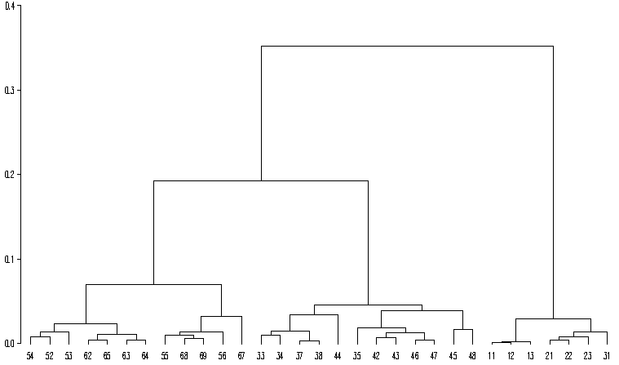

Figure 4 Wage excluded
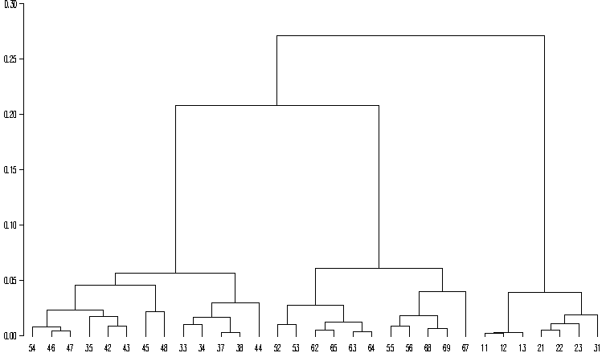

Figure 5 Initial education excluded
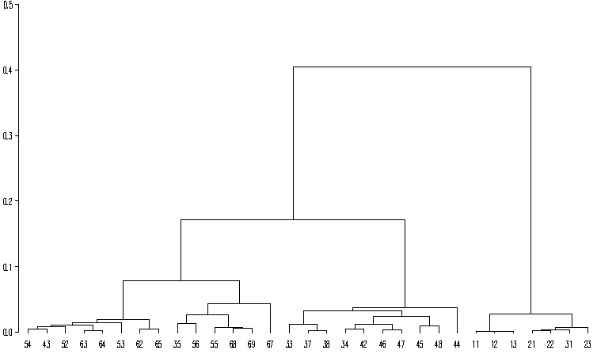

Figure 6 Supervisory resp. excluded
