Validation of ESeC: The Effect of Coding Procedures and Occupational Aggregation Level

Cornelia Hausen, Jean-Marie Jungblut, Walter Müller, Reinhard Pollak, Heike Wirth

Mannheim, MZES and ZUMA, December 23, 2005
In this paper, we summarize the main findings of the German validation study delivered in our draft report in October 2005. In addition, we include a discussion on the problems of generating ESeC with aggregated ISCO-codes (3-digit and 2-digit codes), a comparison of ESeC and EGP and we present some results of a construct validity enterprise using unemployment as an outcome variable.
The main data source for our validation studies of ESeC is a cross-sectional study on the “Acquisition and Application of Occupational Qualifications 1998/99” conducted by the Federal Institute for Vocational Education and Training (BIBB) in collaboration with the Institute for Employment Research” (IAB). The sampling population comprised persons 15 years old and older, carrying out regular, paid employment of at least 10 hours per week. The data set includes questions on employment relationship, supervisory status, position with employer, and the national occupational classification as well as ISCO-88. In total, the data set includes 34343 respondents. For auxiliary analyses, we relied on the German Socio-Economic Panel (GSOEP).
1 Main findings of the validation of ESeC for Germany.
We would like to highlight three issues of our validation study that are crucial to understand ESeC construction for Germany and that potentially raise some problems of general concern:
  - The construction of Employment Status (especially supervisory status) for Germany
  - The validation of the prototype ESeC generation matrix for Germany (validation indicators)
  - Suggestions for revisions of the ESeC matrix and validation of the revisions.
1.1 The construction of Employment Status (especially supervisory status) for Germany
In most of the data sets on Germany, it is uncommon to distinguish between managers, supervisors and other employees. In the public perception, managers are usually understood as top level managers, the concept of a supervisor per se is not well-established, and there are fine distinctions among the group of employees like Arbeiter (workers), Angestellte (white-collar employees), and Beamte (civil servants). So, in fact, almost all relevant data sets in the social sciences include a more detailed classification of “position with employer” (see validation report). Fortunately, our BIBB/IAB data set includes both, a direct measure on supervisory status and a measure on position with employer. We have used the following procedures to mimic the ESeC employment status concept:
Self-Employment was no problem to construct in a way the ESeC group agreed upon. In cases with missing data on number of employees, we assigned those cases to the modal category of all valid observations, i.e. self employed with 1 to 9 employees.
For Managers, we had no specific question addressing managerial status. We decided to identify managerial status with the ISCO 11-, 12- and 13- two digit codes. Managers are all employees who have an ISCO88-COM code between 1100 and 1319. By using additional information on the number of workers employed at the workplace, it was possible to distinguish small managers (ISCO88-COM 1100-1319 in firms with less than 10 employees) from large managers (ISCO88-COM 1100-1319 in firms with 10 or more employees). In the case of missing information on the number of workers employed, we relied on the information ‘size of organisation’ built into the ISCO88-COM codes.
Supervisors and Employees: Among those not previously coded as self-employed or managers, supervisors are distinguished from employees by considering all those as supervisors who indicated to have co-workers for whom the respondent is the direct supervisor (irrespective of the number of co-workers supervised; information on the number of supervised is not available).
As the Swedish colleagues pointed out, this leads to a rather broad (probably too broad) definition of supervisors, that also includes workers for whom supervision is not the main task. We think it is very important to clarify the concept of a supervisor and establish an internationally agreed procedure to measure supervisory function. Specific recommendations should be made for such procedures to the national and international data collection agencies, also to those in the social sciences such as ESS or ISSP.
However, the most important databases such as the Microcensus, GSOEP, ALLBUS usually do not include information of co-workers supervised. For these cases we developed and examined a proxy measure of supervisory function. We use the variable “Position with Employer” (PwE), which distinguishes 14 types of work positions, partly corresponding to formally established distinctions. In some of these work positions workers usually have supervisory functions, in others they don’t. As a proxy measure for supervisors we consider all positions with employers as supervisory positions in which at least 50% of the respondents in the BIBB/IAB data have supervisory functions (in fact, in most positions coded as supervisory positions 75% or more workers have supervisory functions). Compared to the standard measure, this proxy measure strongly underestimates the number of supervisors. Only 26% of the respondents who have co-workers they supervise are correctly identified as supervisors by the proxy procedure; but 74% of all those coded as supervisor by the proxy procedure do in fact have co-workers they supervise. Most of those who are identified as supervisors by this proxy measure are likely to be true supervisors.
How does the bias created with the proxy measure carry over to ESeC classes? In terms of ESeC classes 11% of all cases are coded differently by the proxy procedure compared to the international standard question on supervisory status (see table 1.1). At large, the difference between both procedures is limited, but the deviations clearly vary by class. The self-employed classes and the higher salariat class (ESeC 1) are not affected at all. Those cases which go into ESeC classes 3, 7, 8, 9 using the standard procedure go basically to the same ESeC class if we use the proxy procedure (row percentages). However, this is not the case for class 2: about 16% of standard ESeC 2 are allocated in proxy ESeC 3. If we look at column percentages, it is again classes 2 and 3 and in particular class 6 that show differences between standard and proxy versions of employment status. For ESeC 6, about 61% of the standard version members are recoded into a proxy ESeC class further down the class structure (half of them into lower technicians, and the other half into the lower service or into the routine occupations class).

Table 1.1 | Distribution of ESeC-Classes: Using the Supervisory Function vs. the Proxy PwE measure for Generating Supervisor Status (BIBB/IAB, 1999).
Supervisors defined by Supervisory Function | Supervisor Proxy defined by Position with Employer using 50% rule
Supervisors defined by Supervisory Function | 1.  Higher S. Occ. | 2. Lower S. Occ. | 3. Interm. Occ. | 4.  Self E. N-Prof. | 5.  Self E. Agr. | 6.  Lower Sup. | 7.  Lower Serv. | 8.  Lower Techn. | 9.  Routine Occ. | Total
Supervisors defined by Supervisory Function | (%) | (%) | (%) | (%) | (%) | (%) | (%) | (%) | (%) | (%)
1. Higher S.O. | 4.237 | 0 | 0 | 0 | 0 | 0 | 0 | 0 | 0 | 4.237
 | 100.0 | 0.0 | 0.0 | 0.0 | 0.0 | 0.0 | 0.0 | 0.0 | 0.0 | 100.0
 | 100.0 | 0.0 | 0.0 | 0.0 | 0.0 | 0.0 | 0.0 | 0.0 | 0.0 | 12.4
2. Lower S.O. | 0 | 7.193 | 1.359 | 0 | 0 | 6 | 105 | 0 | 0 | 8.663
 | 0.0 | 83.0 | 15.7 | 0.0 | 0.0 | 0.1 | 1.2 | 0.0 | 0.0 | 100.0
 | 0.0 | 98.1 | 24.4 | 0.0 | 0.0 | 0.4 | 3.3 | 0.0 | 0.0 | 25.4
3. Intermed. O. | 0 | 122 | 4.222 | 0 | 0 | 0 | 0 | 0 | 0 | 4.344
 | 0.0 | 2.8 | 97.2 | 0.0 | 0.0 | 0.0 | 0.0 | 0.0 | 0.0 | 100.0
 | 0.0 | 1.7 | 75.7 | 0.0 | 0.0 | 0.0 | 0.0 | 0.0 | 0.0 | 12.7
4. Self E. N-Prof. | 0 | 0 | 0 | 2.276 | 0 | 0 | 0 | 0 | 0 | 2.276
 | 0.0 | 0.0 | 0.0 | 100.0 | 0.0 | 0.0 | 0.0 | 0.0 | 0.0 | 100.0
 | 0.0 | 0.0 | 0.0 | 100.0 | 0.0 | 0.0 | 0.0 | 0.0 | 0.0 | 6.7
5. Self E. Agr. | 0 | 0 | 0 | 0 | 78 | 0 | 0 | 0 | 0 | 78
 | 0.0 | 0.0 | 0.0 | 0.0 | 100.0 | 0.0 | 0.0 | 0.0 | 0.0 | 100.0
 | 0.0 | 0.0 | 0.0 | 0.0 | 100.0 | 0.0 | 0.0 | 0.0 | 0.0 | 0.2
6. Lower Sup. | 0 | 1 | 0 | 0 | 0 | 1.306 | 465 | 1.044 | 533 | 3.349
 | 0.0 | 0.0 | 0.0 | 0.0 | 0.0 | 39.0 | 13.9 | 31.2 | 15.9 | 100.0
 | 0.0 | 0.0 | 0.0 | 0.0 | 0.0 | 85.9 | 14.6 | 20.3 | 11.2 | 9.8
7. Lower Serv. | 0 | 20 | 0 | 0 | 0 | 28 | 2.615 | 0 | 0 | 2.663
 | 0.0 | 0.8 | 0.0 | 0.0 | 0.0 | 1.1 | 98.2 | 0.0 | 0.0 | 100.0
 | 0.0 | 0.3 | 0.0 | 0.0 | 0.0 | 1.8 | 82.1 | 0.0 | 0.0 | 7.8
8. Lower Techn. | 0 | 0 | 0 | 0 | 0 | 137 | 0 | 4.099 | 0 | 4.236
 | 0.0 | 0.0 | 0.0 | 0.0 | 0.0 | 3.2 | 0.0 | 96.8 | 0.0 | 100.0
 | 0.0 | 0.0 | 0.0 | 0.0 | 0.0 | 9.0 | 0.0 | 79.7 | 0.0 | 12.4
9. Routine O. | 0 | 0 | 0 | 0 | 0 | 43 | 0 | 0 | 4.215 | 4.258
 | 0.0 | 0.0 | 0.0 | 0.0 | 0.0 | 1.0 | 0.0 | 0.0 | 99.0 | 100.0
 | 0.0 | 0.0 | 0.0 | 0.0 | 0.0 | 2.8 | 0.0 | 0.0 | 88.8 | 12.5
Total | 4.237 | 7.336 | 5.581 | 2.276 | 78 | 1.52 | 3.185 | 5.143 | 4.748 | 34.104
 | 12.4 | 21.5 | 16.4 | 6.7 | 0.2 | 4.5 | 9.3 | 15.1 | 13.9 | 100.0
 | 100.0 | 100.0 | 100.0 | 100.0 | 100.0 | 100.0 | 100.0 | 100.0 | 100.0 | 100.0

Conclusions and recommendations
Both for reasons of theoretical consistency and measurement comparability the use of the proxy procedure thus at best can be legitimated only because for several core databases no better alternative solution appears to be available. However, when using it, the following considerations should be taken into account:
- Because of serious distortions in particular in coding ESeC class 6 we recommend to aggregate ESeC classes 6 (”Lower Supervisory / Lower Technicians”) and ESeC class 8 (“Lower Technical Occupations”) when direct measures of supervisory function are not available. The combined proxy classes 6 and 8 then only include about 1% cases that are not coded ESeC 6 and 8 by the standard procedure. However, of the cases coded ESeC 6 and 8 by the standard procedure only 87% will receive the same codes by the proxy procedure; about 6% will be coded as Lower Service (ESeC 8) and 7% as ESeC 9. Each of the latter proxy classes will be somewhat larger than under standard coding because they include some 10-15% of standard code supervisors, while the combined proxy classes ESeC 7 and 9 will be somewhat smaller than under the standard procedure (about 20% instead of 22%).
- One might also consider aggregating ESeC classes 2 and 3. This, however, makes less sense theoretically and it is also somewhat less compelling in view of the numbers involved. It, however, must be kept in mind, that the proxy version overestimates the size of ESeC class 3 (16% instead of 13%) because proxy ESeC 3 also includes some higher level supervisors that are coded as ESeC 2 in the standard procedure. For the same reason the size of proxy ESeC class 2 is smaller than standard ESeC 2 (22% instead of 25%).
- The use of the proxy procedures does not only have implications for the marginal distributions. The proxy ESeC classes 3, 7 and 9 will be more heterogeneous than the corresponding standard classes because they also include a selection of supervisors that are not part of these classes under the standard procedure. For this reason, these proxy classes should also have employment relations that include somewhat more elements of the service relationship than the same classes constructed with the standard procedure.
1.2 The validation of the prototype ESeC generation matrix for Germany
In order to assess the criterion validity of the ESeC class scheme and its operationalization by the ESeC matrix we basically pursued three steps: We first defined a number of indicators of the types of employment relations (ER) characteristic for the various classes as theoretically outlined in Goldthorpe’s conception of his class scheme. Second, from these indicators, we calculated ER-scores for all (empirically available) cells of the OUG*Employment Status Matrix containing the basic units of the ESeC classes. Based on these indicators we reviewed the cells of the prototype V3 ESeC matrix and examined the plausibility of the class codes assigned to the cells of the matrix, and if – according to the empirical evidence – a revision appeared appropriate for the German case, we suggested class codes that are more consistent with the ER indicators. Last, we carried out tests to ascertain whether the revisions proposed in the second step in fact lead to improvements of the class coding, in particular in view of the within-class homogeneity and the between-class differences in employment relations. In this section, we introduce our employment relationship indicators, before we present our results and suggestions in the section 1.3.
Based on the theoretical conception underlying ESeC we defined four sets of indicators to test the construct validity of ESeC (cf. pp. 17 onwards in our validation report):
1: Monitoring problems: Unfortunately, the BIBB/IAB data set does not include direct measures on monitoring problems. Some selected aspects of work autonomy seemed closest to the concept of monitoring problems. We used a factor score derived from three items.
2. Asset specificity includes two measures indicating the level and kind of qualifications required at the job (self-reported item).
3. Career prospects: Again, we do not have a direct measure of career perspectives in our data. As an indicator, we use received further education in the last five years (with present employer). Admittedly, this indicator is far from perfect. But we think it can be seen as one form of an employer’s investment into his or her employee. An employer would certainly abstain from conducting training programs for employees with short perspectives within the firm.
4. Long term employment: The indicator we use is tenure residuals, that is a measure of the residuals of a regression, that predicts number of years with the current employers controlling for number of years elapsed since first employment and for gender (as women interrupt their working life more often than men). If the observed residuals from the prediction positively deviate from the predicted value for a given class or a given OUG this means, that experienced tenure in this class or OUG is higher than the expected average for given gender and number of years in the labour force.
Figure 1.1: Summary of validation indicators for BIBB/IAB
Work Autonomy,  Means of Factor Score (BIBB) | Asset Specificity: adjusted highest degree: % requiring foreman education/college (BIBB/IAB
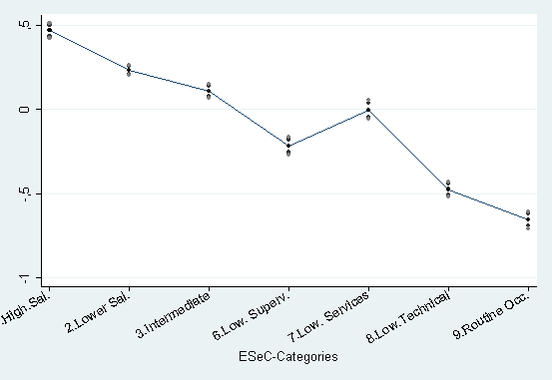 | 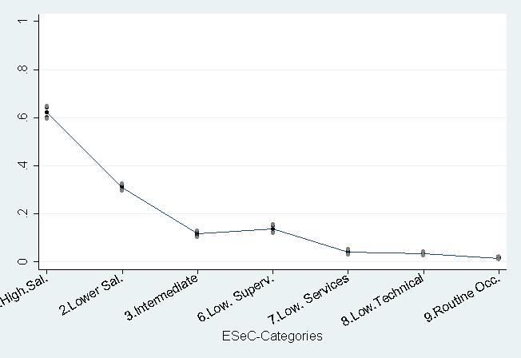
Asset Specificity: adjusted highest degree: % requiring any degree (BIBB/IAB) | Long-Term Employment: tenure residuals (BIBB/IAB)
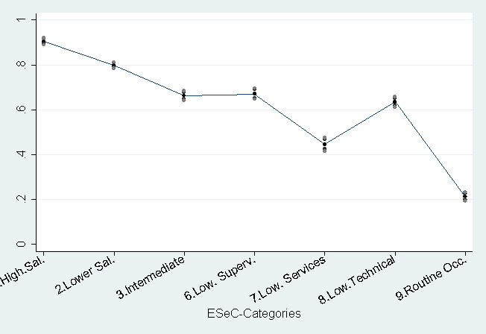 | 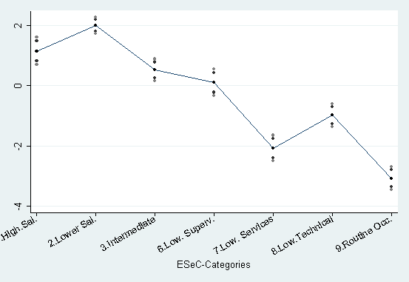
Career Prospects % having obtained further education (BIBB/IAB) | Career Prospects: factor scores (GSOEP)
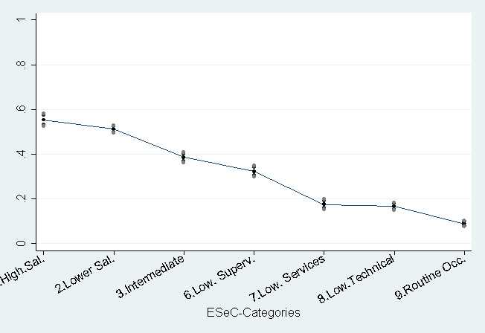 | 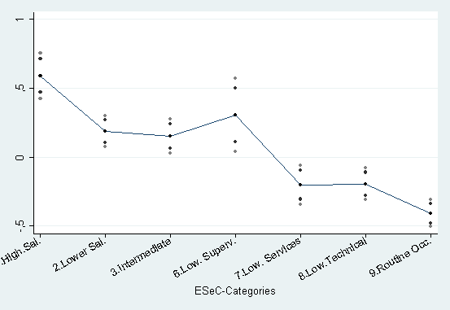

Results
Figure 1.1 shows in a summary way the variation of the main validation indicators by class for the BIBB/IAB database (and for the GSOEP Career Prospect measure). Classes are defined by the ESeC class categories constructed with the prototype ESeC matrix. For obvious reasons, we only include employed persons in the analysis.
In sum, the graphs included in Figure 1.1 show that the prototype ESeC classes are clearly related in a theoretical consistent and empirically confirmed way to the validation criteria. Of course, not every indicator discriminates all ESeC classes in a unanimous way. It is rather the overall pattern and the interplay of the indicators that nicely discriminate between different classes. We therefore have sufficient reasons to use them for the micro-examination of the prototype ESeC matrix, looking at each empirical OUG*employment status constellation separately.
1.3 Revision of the prototype ESeC matrix V3
In examining the prototype ESeC matrix V3 (last correction: June 14, 2005) and making suggestions to revise the matrix, we followed the idea of keeping national changes to the prototype matrix limited, i.e. we did not push forward every minor (small N) case for revision. Nevertheless, our empirical analysis suggested a number of OUG*Employment status cells to be revised. In Table 1.2, we provide a list of all the combinations for which we think it is worth asking other countries to investigate. Our validation report presented a short explanation for each revision. In this paper, we will only highlight some prominent changes which may be of interest for other countries as well.
Secondary education teachers (2320) are a heterogeneous group in terms of educational requirements (higher vs. lower tertiary education), position in the civil service hierarchy and income. Especially upper secondary education teachers at the Gymnasium in Germany should clearly go into class 1 (and if we remember correctly, similar issues should apply to Sweden and the Netherlands). However, if we base our judgment on our ER scores, all secondary teachers should go into class 1, because their ER scores are consistently higher than the average of class 1. Yet, our education required indicator cannot distinguish between higher and lower tertiary education, so we are somewhat hesitant to stick to the proposal of putting all secondary teachers into class 1. We propose a split of OUG 2320 into a new OUG 2321 for upper secondary education teachers at Gymnasium (ESeC class 1) and all other teachers of the former joint OUG go into 2322 and remain ESeC class 2.
Public service administrative professionals (2470) build a large group within Germany’s large public sector. Their autonomy scores are rather low and point towards ESeC 2, while other ER indicators are consistent with ESeC 1. However, their level of employment in the civil service hierarchy – as measured by the Position-with-Employer variable - clearly groups them into ESeC 2. Therefore we suggest ESeC 2 for employees while supervisors remain in class 1.
Technicians: For several technician OUG’s, the ER indicators for employees point to ESeC 6 rather than to ESeC 2 in Germany (ISCO88: 3111, 3118, 3133, 3152, 3211, 3212 and 3224). This might be due to a limited level of education required (below college or polytechnics level) and due to the fact that Germany has a large number of engineers who block career mobility of technicians. Supervisors should remain in ESeC 2, but self-employed in consequence move from ESeC 2 to ESeC 4.
Table 1.2: Suggested OUG by Employment Status combinations for revision
OUG |  | Employment Status³ | Prototype | German Matrix | # of cases switched
1233 | Sales and marketing managers | 4 | 1 | 2 | 152
2321 | Upper secondary education teachers at Gymnasium | 6 | 2 | 1 | 48
2321 | Upper secondary education teachers at Gymnasium | 7 | 2 | 1 | 210
2432 | Librarians and related information professionals | 6 | 2 | 1 | 25
2460 | Religious professionals | 6 | 2 | 1 | 36
2460 | Religious professionals | 7 | 2 | 1 | 16
2470 | Public service administrative professionals | 7 | 1 | 2 | 197
3111 | Chemical and physical science technicians | 7 | 2 | 6 | 94
3113 | Electrical engineering technicians | 6 | 6 | 2 | 27
3113 | Electrical engineering technicians | 7 | 6 | 2 | 47
3118 | Draughtspersons | 7 | 2 | 6 | 112
3133 | Medical equipment operators | 7 | 2 | 6 | 19
3152 | Safety, health and quality inspectors | 7 | 2 | 6 | 96
3211 | Life science technicians | 7 | 2 | 6 | 93
3212 | Agronomy and forestry technicians | 7 | 2 | 6 | 7
3224 | Optometrists and opticians | 7 | 2 | 6 | 26
3340 | Other teaching associate professionals | 7 | 7 | 2 | 72
3419 | Finance and sales associate professionals not elsewhere classified | 7 | 2 | 3 | 419
3429 | Business services agents and trade brokers not elsewhere classified | 7 | 2 | 3 | 101
3460 | Social work associate professionals | 7 | 2 | 3 | 230
4113 | Data entry operators | 6 | 2 | 6 | 4
4211 | Cashiers and ticket clerks | 6 | 2 | 6 | 26
4211 | Cashiers and ticket clerks | 7 | 3 | 7 | 141
5122 | Cooks | 7 | 8 | 9 | 253
5123 | Waiters, waitresses and bartend | 7 | 9 | 7 | 212
5132 | Institution-based personal care workers | 7 | 7 | 3 | 445
6121 | Dairy and livestock producers | 7 | 8 | 9 | 10
7129 | Building frame and related trades workers not elsewhere classified | 7 | 8 | 9 | 56
7133 | Plasterers | 7 | 8 | 9 | 28
7134 | Insulation workers | 7 | 8 | 9 | 39
7139 | Building finishers and related trade workers not elsewhere classified | 7 | 8 | 9 | 22
7221 | Blacksmiths, hammer-smiths and forging-press workers | 7 | 9 | 8 | 8
7245 | Electrical line installers, repairers and cable joiners | 7 | 6 | 8 | 7
7413 | Dairy-products workers | 7 | 9 | 8 | 7
7421 | Wood treater and wood seasoner | 7 | ² | 8 | 1
7441 | Pelt dressers, tanners and fellmongers | 7 | 9 | 8 | 3
7442 | Shoe-makers and related workers | 7 | 9 | 8 | 10
8121 | Ore and metal furnace operators | 7 | 8 | 9 | 5
8278 | Brewers, wine and other beverage machine operators | 7 | 9 | 8 | 8
8323 | Bus and tram drivers | 7 | 9 | 8 | 96
2 not included in prototype
3 Employment status: 4 = Man>=10; 6 = Supervisors; 7 = Employee

Institution-based personal care workers (5132): This is a large group in Germany. It comprises mainly positions as medical doctors’ aids or dental doctors’ aids in medical practices (ranked #1 and #3 in the list of the most favourite vocational training programs for women). In contrast to ESeC class 7, these jobs have, on average, better career and long-term employment prospects and higher qualification is required. Employees should be coded into ESeC 3.
- In terms of class reallocations (see table 1.3), the most numerous cases (cells which represent between 1 and 2% of all respondents) involve switches from
- the higher salariat to the lower salariat, involving the sales and marketing managers, and the public service administrative professionals;
- the lower salariat to the higher salariat, involving mainly gymnasium teachers, librarians and the religious professionals
- the lower salariat to the intermediate occupations, involving mainly finance and sales associate professionals nec, business service agents and trade brokers nec and social work associate professionals
- the lower salariat to the lower technicians, involving mainly chemical, physical and life science technicians, draughtspersons, safety, health and quality inspectors and optometrists and opticians;
- the lower service occupations to intermediate occupations, involving mainly Institution-based personal care workers (in Germany mainly medical and dental doctors’ aids).
- From lower technical occupations to routine occupations, and
- From routine occupations to lower technical or lower service occupations

Table 1.3 | Number of cases coded differently into ESeC classes in prototype V3 matrix and in German variant of ESeC matrix (BIBB/IAB, 1999).
Assignments for German variant of ESeC matrix | Assignments according to prototype V3 matrix
Assignments for German variant of ESeC matrix | 1.  Higher S. Occ. | 2. Lower S. Occ. | 3. Interm. Occ. | 4.  Self E. N-Prof. | 6.  Lower Sup. | 7.  Lower Serv. | 8.  Lower Techn. | 9.  Routine Occ. | Total
1. Higher S.O. | 0 | 338 | 0 | 0 | 0 | 0 | 0 | 0 | 338
2. Lower S.O. | 349 | 0 | 0 | 23 | 74 | 72 | 0 | 0 | 518
3. Intermed. O. | 0 | 750 | 0 | 0 | 0 | 445 | 0 | 0 | 1.195
4. Self E. N-Prof. | 0 | 135 | 0 | 0 | 0 | 0 | 0 | 0 | 13
6. Lower Sup. | 0 | 477 | 0 | 0 | 0 | 0 | 0 | 0 | 477
7. Lower Serv. | 0 | 0 | 141 | 0 | 0 | 0 | 0 | 212 | 353
8. Lower Techn. | 0 | 0 | 0 | 0 | 7 | 0 | 0 | 132 | 139
9. Routine O. | 0 | 0 | 0 | 0 | 0 | 0 | 413 | 0 | 413
Total | 349 | 1700 | 141 | 23 | 81 | 517 | 413 | 344 | 3.568

1.4 Assessment of the ESeC-Matrix revisions
In this section we focus on
- the implications the revisions have for the distribution of classes,
- the implications they in terms of the validation criteria on the within-class homogeneity and between class differences

(1) ESeC distributions resulting from different allocation matrices
Table 1.4 shows the distribution of cases along the ESeC classes that are obtained for the different procedures described before. Column (1) includes the distribution based on the international prototype V3 ESeC generation matrix, proposed by the coordinator. Column (2) shows the distribution for the revised matrix for Germany. Columns 3-6 report the same results separated for men and women.
As expected, the differences between the two versions are most pronounced for the lower salariat (ESeC 2) and intermediate occupations (ESeC 3), the latter being nurtured from both downward switches from the lower salariat and upward switches from the lower service occupations. Also ESeC 6 is somewhat larger in the German ESeC version than in the prototype because some technician occupations have been moved from the lower salariat to this class. Through these changes the salariat (ESeC 1 and 2) declines from 37,8% to 34,7%; the intermediate classes (ESeC 3-6) grow from 29,6% to 33,1%, while classes ESeC 7-9 decline from 32,6 to 31,5%.
An interesting pattern turns up in the gender differences of the class distributions resulting from the prototype and the German ESeC (columns 3-6 in Table 5). For both procedures, the typical pattern of gender segregation in jobs and class positions is clearly evident (less women than men in the higher salariat, in self-employment and in the supervisory, lower technicians, lower technical and routine occupations; but more women than men in the lower salariat and in the intermediate and lower service occupations). However, the OUG’s which have been moved from ESeC 2 to ESeC 3 must be occupational unit groups mainly occupied by women. While with the changes from the prototype ESeC to the German ESeC the decline of the lower salariat and the increase of intermediate occupation is only about 1 percentage point for men, the respective changes for women are larger than 5 percentage points. In consequence, the discrepancies in the distributions of men and women along more or less advantageous class positions turn out to be more pronounced with the ESeC matrix based on the German validation criteria than on those based on the prototype criteria. The more pronounced gender discrepancies turn up even though the decision to reallocate some of the OUG’S was exclusively based on the validation criteria and no gender concerns were involved, neither in the construction of the validation criteria nor in their application.
For the ESeC versions based on the proxy-coding for employment status the pattern of changes is the same, but the sizes of the differences between the prototype class distribution and the distribution based on the nation specific version of the ESeC generation matrix are slightly larger (results not shown).
Tab. 1.4:ESeC class distributions resulting from international prototype and German country-specific ESeC generation matrices
 | BIBB/IAB
 | Prototype | German | Prototype Men | German Men | Prototype Women | German Women
 | (1) | (2) | (3) | (4) | (5) | (6)
1. Higher Salariat Occupations | 12.4 | 12.4 | 16.5 | 16.2 | 7.2 | 7.4
2. Lower Salariat Occupations | 25.4 | 21.9 | 21.2 | 19.6 | 30.9 | 24.9
3. Intermediate Occupations | 12.8 | 15.9 | 6.1 | 7.4 | 21.4 | 26.9
4.Self employed and small employer | 6.8 | 7.1 | 7.3 | 7.6 | 6.1 | 6.5
5.Self employed and small employer (Agr) | 0.2 | 0.2 | 0.2 | 0.2 | 0.3 | 0.3
6. Lower Supervisory / Technician Occ. | 9.8 | 11.0 | 13.5 | 14.0 | 5.0 | 7.1
7. Lower Services / Sales / Clerical Occ. | 7.8 | 7.3 | 2.7 | 2.7 | 14.3 | 13.2
8. Lower Technical Occupations | 12.4 | 11.6 | 18.5 | 18.0 | 4.5 | 3.3
9. Routine Occupations | 12.4 | 12.6 | 14.0 | 14.2 | 10.4 | 10.5
N | 33,611 | 33,611 | 18,995 | 18,995 | 14,616 | 14,616

(2) Criterion validity of the different allocation matrices
How do the revisions suggested for the German variant of the ESeC matrix affect the construct validity of the class schema when assessed through our validation indicators? To this aim, we present two sets of results
(a) Measures of R² or Pseudo R² (in the case of logistic regression) for models which regress the various validation criteria on the dummy-coded ESeC classes, constructed under the various procedures already described above.
(b) We show how the class specific means of the different validation indicators vary by procedures.
Ad (a): Variance of the different validation indicators explained by class is a very rudimentary assessment of validity, but when R² increases, this indicates that more variance in the criterion variables is between classes and less within classes, i.e. the within-class homogeneity declines and the between class differences increase.
For the ΒΙΒΒ/ΙΑΒ data R² increases for all validation criteria when we move from the prototype to the German country specific variant of the ESeC matrix. This is not a big surprise because we used the validation criteria to reallocate OUG’s. However, the increase at least shows, that there was some substantial room to improve class internal homogeneity and to sharpen the between class profile for the German case. We would like to emphasize here that we did not use any kind of automatic optimization procedure and we were concerned about the general theoretical meaningfulness of reallocations. An important result also is, that variance explained improves for all criteria, and not for instance for one criterion to the expense of others. This does indicate that the reallocations do justice to the broad and multidimensional nature of class characteristics. It would be important to check for additional criteria.
Tab.1.5: Variance explained in validation criteria with prototype and country-specific ESeC generation matrix
 | BIBB/IAB
 | Prototype | German | Prototype proxy | German proxy
Work Autonomy Factor | 13.4 | 14.2 | 13.6 | 14.3
Asset Specificity  Any degree | 14.8 | 17.0 | 15.4 | 17.6
Master, College | 22.1 | 25.2 | 23.2 | 26.7
Career Prospects | 10.6 | 11.8 | 10.2 | 11.2
Long-term Employment. | 4.6 | 5.4 | 4.4 | 5.3
 |  |  | GSOEP
 |  |  | Prototype proxy | German proxy
Work Autonomy Factor |  |  | 10.4 | 10.4
Delegated Authority |  |  | 10.2 | 9.9
Asset Specificity  Only introduction to job |  |  | 24.2 | 27.0
College required |  |  | 28.5 | 33.7
Career Prospects Factor |  |  | 9.4 | 9.4
Long-term Employment |  |  | 4.1 | 4.6

At large, the results for the GSOEP data point in similar direction. For two indicators the results do not change, for three validation criteria R² for the German country specific ESeC matrix is (partly considerably) larger, for one criterion R² is slightly smaller. The results are thus less unambiguous, but there is clearly more improvement than decline. R² increases especially strongly for the asset specificity criteria, also for “only introduction to the job”, that was not included among the criteria used to examine the prototype matrix and for reallocation. All this is likely related to the strong role of qualifications in the German labour market and social structure. The ambiguity of results may be partly due to the large sample errors that we have seen in the GSOEP data.
(b) A second way to assess the validity implications of the suggested revisions is to compare the class means of the validation indicators obtained by the revised German matrix and the prototype matrix. Results can be seen from the following figure 1.2, where we also present the within-class standard deviations obtained by each matrix as direct measure of the within class heterogeneity.
For working autonomy the changes resulting from the revisions are very minor. Considering both the means and the standard deviations, we can conclude that the raise in variance explained (when moving from the prototype to the German version) that we see in table 1.5, does hardly result from different class specific means, rather it results from slightly smaller within class standard deviations in the German version of the matrix, indicating slightly increased within-class homogeneity in some of the classes.
Concerning the two indicators of Asset Specificity the revisions lead to some improvements in both aspects: Class means differ more from each other in the German than in the prototype version, and standard deviations tend to be smaller in the German than in the prototype version. In terms of changes in the means, the most clear-cut implication of the revisions is that the lower services class (ESeC 7) is more distinctively identified as a class with jobs requiring little qualifications, and the class becomes also more homogeneous in this respect. A second implication is that the salariat classes differ slightly more from all other classes in requiring higher qualifications, and the higher salariat becomes also slightly more homogeneous in this respect.

Figure 1.2: ER-Indicators for the revised German matrix (GE) and the prototype matrix (PE) BIBB/IAB (1999) N = 29,407.
Work Autonomy, Means of Factor Scores, (BIBB/IAB) |  |  |  |  |  |  |  | Asset Specificity: % requiring foreman /college education (BIBB/IAB)
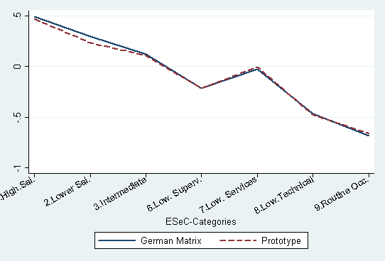 |  |  |  |  |  |  |  | 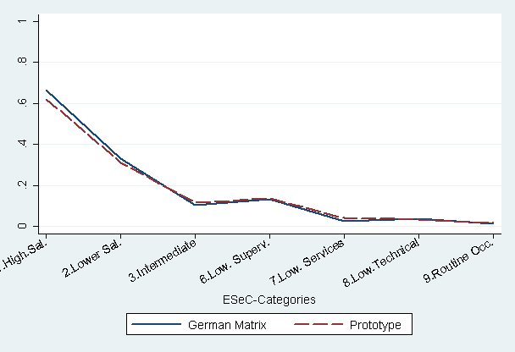
 | Standard Deviation ESeC |  |  |  |  |  |  |  |  | Standard Deviation ESeC
 | 1 | 2 | 3 | 6 | 7 | 8 | 9 |  |  | 1 | 2 | 3 | 6 | 7 | 8 | 9
GE | 0.81 | 0.9 | 0.88 | 0.97 | 0.95 | 0.98 | 1 | GE |  | 0.47 | 0.47 | 0.31 | 0.34 | 0.15 | 0.19 | 0.12
PT | 0.83 | 0.9 | 0.88 | 0.98 | 0.95 | 0.97 | 1 | PT |  | 0.49 | 0.46 | 0.32 | 0.34 | 0.20 | 0.18 | 0.13
Asset Specificity: % requiring any degree (BIBB/IAB) |  |  |  |  |  |  |  | Long-Term-Employment: Tenure Residuals, BIBB/IAB
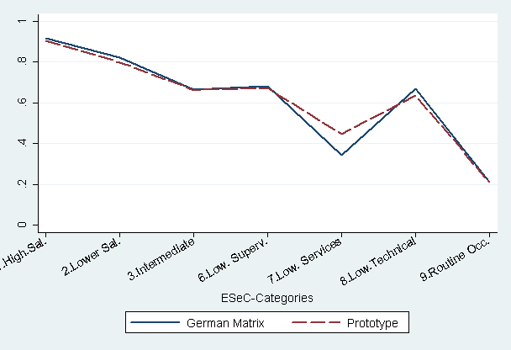 |  |  |  |  |  |  |  | 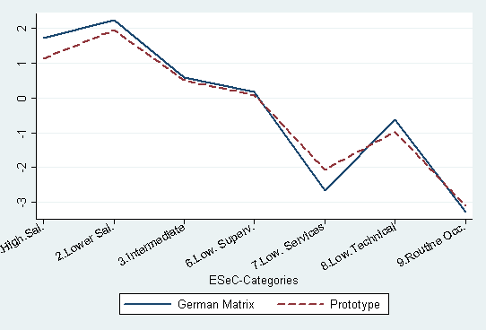
 | Standard Deviation ESeC |  |  |  |  |  |  |  |  | Standard Deviation ESeC
 | 1 | 2 | 3 | 6 | 7 | 8 | 9 |  |  | 1 | 2 | 3 | 6 | 7 | 8 | 9
GE | 0.28 | 0.38 | 0.47 | 0.47 | 0.47 | 0.47 | 0.41 | GE |  | 8.10 | 8.20 | 7.70 | 8.20 | 6.90 | 8.10 | 7.90
PT | 0.29 | 0.40 | 0.47 | 0.47 | 0.50 | 0.48 | 0.41 | PT |  | 8.20 | 8.10 | 7.80 | 8.30 | 7.10 | 8.00 | 7.80
Career Prospects % having obtained further education (BIBB/IAB)
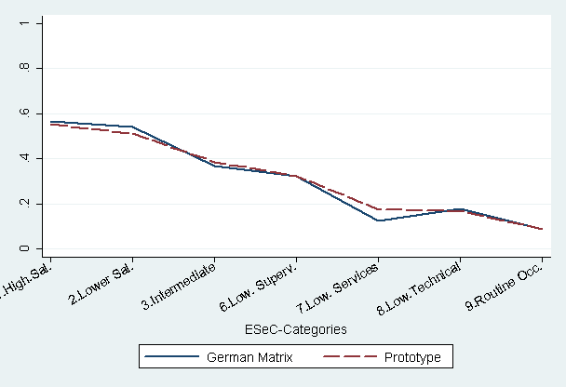 |  |  |  |  |  |  |  |  |  | Standard Deviation ESeC
 |  |  |  |  |  |  |  |  |  | 1 | 2 | 3 | 6 | 7 | 8 | 9
 |  |  |  |  |  |  |  |  | GE | 0.50 | 0.50 | 0.48 | 0.47 | 0.33 | 0.38 | 0.28
 |  |  |  |  |  |  |  |  | PT | 0.50 | 0.50 | 0.49 | 0.47 | 0.38 | 0.37 | 0.29
Figure 1.3 compares the class means of four ER indicators for the GSOEP data. In comparing the GSOP results with the BIBB/IAB data we have to keep in mind that with the GSOEP we have to use the proxy procedure to construct employment status. Therefore results will partly differ. They will also differ because none of the ER-indicators could be defined in exactly the same way in both datasets. This, however, does not affect the comparison of results of the prototype and the German variant of the ESeC matrix in each of the graphs in Figure 1.3. In this respect, we find results that in most cases are consistent with those for the BIBB/IAB data. In particular, but with the exception of work autonomy, the lower services class (ESeC 7) is more similar to the routine occupations with the German matrix than with the prototype matrix (dashed lines). With respect to the requirement of higher education, the salariat classes also differ slightly more from the other classes with the German matrix than with the prototype matrix.
Figure: 1.3: Means of ER-indicators by ESeC class for GSOEP data (N=2,322)
Work autonomy: add. Index, SOEP |  |  | Career Prospects: Factor Scores, SOEP
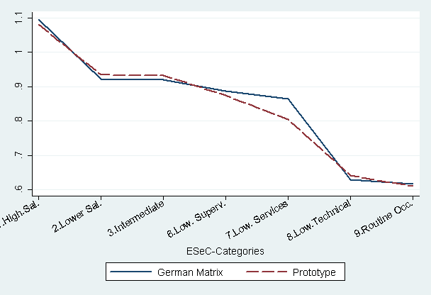 |  |  | 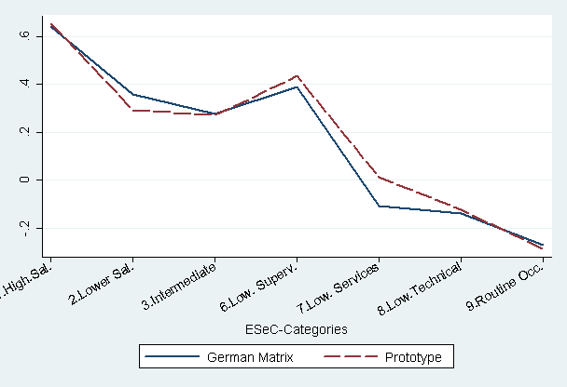
 | Standard | German |  | Standard | German
R² | 0.042 | 0.042 | R² | 0.081 | 0.082
% Master or College required for the job, SOEP |  |  | % only short introduction required for the Job,, SOEP
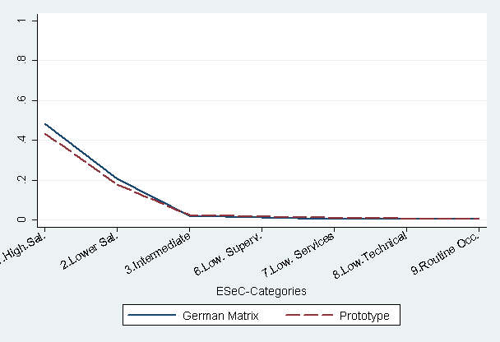 |  |  | 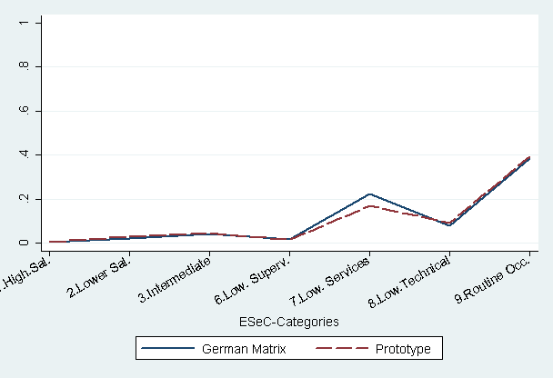
 | Standard | German |  | Standard | German
Pseudo R | 0.252 | 0.296 | Pseudo R | 0.223 | 0.236

All in all, the results show that ESeC is a valid instrument to measure the class aspects it intends to grasp and that with the revisions suggested some improvement in this respect can be achieved for Germany.
The differences in class distributions obtained through the different procedures are substantial, in particular the gender specific distributions. Results appear to sensitively depend on a few seemingly minor decisions and the ESeC team should be very concerned about these issues.

2 Aggregation of ESeC: 2-/3-digit Matrices
This section focuses on the aggregation of the ESeC matrix so it can be used for 3- and 2-digit ISCO codes. As a general rule these matrices are derived by using the modal value for OUGs within the minor group. The aggregation of the matrix involves two main issues to be discussed in the following. The first issue refers to a comparison of the 4-digit, 3-digit and 2-digit matrices. In case a subgroup is heterogeneously composed of, some ISCO-4-digit OUGs get swallowed up by larger OUGs within the minor group. Consequently this comes along with discrepancies in the assigned ESeC classes between the different ESeC versions. One intention of this section is to quantify and discuss these deviances for Germany and to show weather less detailed OUG codes will lead to different results.
The second issue refers to the procedure generating the 3-digit and 2-digit matrices themselves. Since country specific modal values are used to develop the 3- and 2-digit matrices the resulting ESeC codes may vary if the occupational distributions vary between the countries. The 3-digit and 2-digit matrices could differ between countries even if the underlying 4-digit matrix is the same. So the second part of this section deals with different resulting 2- and 3-digit matrices for the UK and Germany.
2.1 Aggregating 2- and 3-digit matrices for Germany
We start with the modified V3 matrix introduced in the previous section. All illicit cells were empty and no simplified class was applied. Thus, only cases with well defined 4-digit ISCO values were used.
To generate a valid 3-digit matrix for Germany for each combination of ISCO-3-digits and employment status, the modal ESeC-class frequency of the 4-digit distribution has been generated. This modal value has been used for all ISCO 3-digits by employment status combinations having 20 or more observations. In all other cases the UK prototype has been used. Open cells were also filled with the UK prototype. The 2-digit OUG’s were generated the same way. Furthermore, the simplified class was calculated separately for ESeC-3-digit and ESeC-2-digit, using the modal frequencies of ESeC 4-digit as a reference.
The resulting distribution of this aggregation is shown in table 2.1. In the following we concentrate on the observations clearly allocated. All observations without any specification of employment status or which are illicit were excluded. Switching from the 4-digit to the 3- and 2-digit, the size of class 1 varies between 12.8 and 10.5%, while classes 6 and 9 decrease. The intermediate occupations (3), self employed (4, 5) and lower services, sales and clerical occupations (8) are nearly constant. In the 3-digit version class 2 grows substantially, while in the 2-digit version mainly class 9 increases. In particular the 3-digit version differs quite markedly from the 4-digit version.

Table 2.1: Distribution of ESeC 4-, 3-, and 2-digit (base: German matrix without simplified class), BIBB/IAB.
ESeC | 4-digit |  | 3-digit |  | 2-digit
1. Higher Salariat Occupations | 4,167 | (12.4) | 3,525 | (10.5) | 3,994 | (11.9)
2. Lower Salariat Occupations | 7,366 | (21.9) | 8,478 | (25.2) | 7,259 | (21.6)
3. Intermediate Occupations | 5,339 | (15.9) | 5,434 | (16.2) | 5,573 | (16.6)
4. Self employed (Non-Prof.) | 2,392 | (7.1) | 2,467 | (7.3) | 2,467 | (7.3)
5. Self employed (Agriculture) | 78 | (0.2) | 78 | (0.2) | 78 | (0.2)
6. Lower Supervisory / Technician Occ. | 3,691 | (11.0) | 3,068 | (9.1) | 3,004 | (8.9)
7. Lower Services / Sales / Clerical Occ. | 2,442 | (7.3) | 2,569 | (7.6) | 3,313 | (9.9)
8. Lower Technical Occupations | 3,894 | (11.6) | 4,120 | (12.3) | 4,132 | (12.3)
9. Routine Occupations | 4,238 | (12.6) | 3,868 | (11.5) | 3,792 | (11.3)
Total | 33,607 | (100.0) | 33, 607 | (100.0) | 33, 607 | (100.0)

To get a better understanding of the reasons of the allocation discrepancies, tables 2.2 and 2.3 show the cross classification between the 4-digit and either 3- or 2-digit versions respectively. Concentrating on the off-diagonals in the 3 versus 4–digit version, we find that for classes 2, 3, 8 and the self employed classes more than 90 percent of the cases receive the same class code in the 3-digit version as in the 4-digit version. For the remainder the correspondence is still above 80%. Similar to the results of the UK (see Interim Report Essex) the differences between 4-digit and 3-digit matrix most often occur for theoretically neighbouring classes which have the same basic form of contract like for classes 1 and 2 (service relationship), or for classes 9, 8 and 7 with a labour contract.
When comparing the ESeC 4- to the 3-digit version, 15% of ESeC 6 are upwardly moved (from ESeC6 to ESeC2) while 13% of ESeC 7 are attributed to ESeC 3. A closer inspection of the flows from the 4-digit to the 3-digit with less than 90% concordance shows that all in all about 52 ISCO codes are involved in classification discrepancies between ESeC classes 1, 6, 7 and 9. The main groups subject to deviances are presented in appendix A.
Since the matrix has been adapted to the German labour market some of the divergences are due to the allocation revisions made for Germany. For example the largest OUG causing the discrepancy between class 1 (4-digit) and class 2 (3-digit) are the upper secondary education teachers at Gymnasium (2321) which have been generated for the German 4-digit matrix and assigned to class 1, while all other OUGs of ISCO 3-digit 232 go to class 2.

Table 2.2: | Distribution of ESeC-Classes: 4-digit vs. 3-digit (BIBB/IAB, 1999).
4-digit OUG’s | 3-digit OUG’s
4-digit OUG’s | 1.  Higher S. Occ. | 2. Lower S. Occ. | 3. Interm. Occ. | 4.  Self E. N-Prof. | 5.  Self E. Agr. | 6.  Lower Sup. | 7.  Lower Serv. | 8.  Lower Techn. | 9.  Rout. Occ. | Total | N
1. Higher S.O. | 84.1 | 14.0 | 0.3 | 1.5 |  |  |  |  |  | 100.0 | 4,167
 | 99.5 | 6.9 | 0.3 | 2.5 |  |  |  |  |  | 12.4
2. Lower S.O. | 0.3 | 98.1 | 0.7 | 0.8 |  | 0.2 |  |  |  | 100.0 | 7,366
 | 0.5 | 85.2 | 0.9 | 2.5 |  | 0.5 |  |  |  | 21.9
3. Intermed. O. |  | 1.2 | 94.8 |  |  |  | 3.4 |  | 0.7 | 100.0 | 5,339
 |  | 0.7 | 93.1 |  |  |  | 7.0 |  | 0.9 | 15.9
4. Self E. N-Prof. |  | 1.9 | 0.1 | 98.0 |  |  |  |  |  | 100.0 | 2,392
 |  | 0.5 | 0.0 | 95.0 |  |  |  |  |  | 7.1
5. Self E. Agr. |  |  |  |  | 100.0 |  |  |  |  | 100.0 | 78
 |  |  |  |  | 100.0 |  |  |  |  | 0.2
6. Lower Sup. |  | 15.2 |  |  |  | 82.3 |  | 2.4 |  | 100.0 | 3,691
 |  | 6.6 |  |  |  | 99.1 |  | 2.2 |  | 11.0
7. Lower Serv. |  |  | 12.6 |  |  |  | 87.3 |  | 0.1 | 100.0 | 2,442
 |  |  | 5.7 |  |  |  | 83.0 |  | 0.1 | 7.3
8. Lower Techn. |  |  |  |  |  | 0.4 |  | 96.6 | 3.1 | 100.0 | 3,894
 |  |  |  |  |  | 0.5 |  | 91.3 | 3.1 | 11.6
9. Routine O. |  |  |  |  |  |  | 6.1 | 6.4 | 87.5 | 100.0 | 4,238
 |  |  |  |  |  |  | 10.0 | 6.6 | 95.9 | 12.6
Total | 3,525 | 8,478 | 5,434 | 2,467 | 78 | 3,068 | 2,569 | 4,120 | 3,868 |  | 33,607
 | 10.5 | 25.2 | 16.2 | 7.3 | 0.2 | 9.1 | 7.6 | 12.3 | 11.5 | 100.0
 | 100.0 | 100.0 | 100.0 | 100.0 | 100.0 | 100.0 | 100.0 | 100.0 | 100.0 | 100.0

The flow from class 6 to 2 is also mainly caused by ISCO 4-digits which have been reallocated. So the two largest OUGs causing the deviance are draughtspersons (ISCO 3118) and chemical and physical science technicians (3111). These OUGs have been reallocated for the German matrix and cause 37% of the movement from class 6 to 2. The movers from class 7 (4-digit) to class 3 (2-digit) are mainly stock clerks (4131). Finally, the maceration of class 9 (4-digit) is mainly caused by cooks (5122) and the building frame and related trades workers not elsewhere classified (7129) with the latter again being the result of reallocations.
Since all OUGs have been controlled en detail with respect to the ER-indicators and the reallocations are theoretically and also empirically grounded, these findings point to the fact that in Germany some ISCO minor groups seem to be quite heterogeneous. Even though the proportion of 92% identical codes in the 4-digit and the 3-digit versions may appear quite high, for some classes the discrepancies are not negligible. Taking a look at the composition of the 3-digit classes it is evident that the 3-digit matrix, at least for Germany, always will lead to a larger heterogeneity (in terms of employment relations indicators) within class 2 and class 7 in particular. Class 2 is diluted by class 6 and class 1 (about 7% in both cases), and class 7 by class 3 and class 9, respectively. Interpreting effects of theses two classes by using the 3-digit matrix one always should have their composition in mind.

Table 2.3: | Distribution of ESeC-Classes: 4-digit vs. 2-digit (BIBB/IAB, 1999).
4-digit OUG’s | 2-digit OUG’s
4-digit OUG’s | 1.  Higher S. Occ. | 2. Lower S. Occ. | 3. Interm. Occ. | 4.  Self E.  Prof. | 5.  Self E. Agr. | 6.  Lower Sup. | 7.  Lower Serv. | 8.  Lower  Techn. | 9.  Rout. Occ. | Total | N
1. Higher S.O. | 81.6 | 16.6 | 0.3 | 1.5 |  |  |  |  |  | 100.0 | 4,167
 | 85.2 | 9.5 | 0.3 | 2.5 |  |  |  |  |  | 12.4
2. Lower S.O. | 8.0 | 78.3 | 9.5 | 0.9 |  | 3.2 |  |  |  | 100.0 | 7,366
 | 14.8 | 79.5 | 12.5 | 2.8 |  | 8.0 |  |  |  | 21.9
3. Intermed. O. |  |  | 85.5 |  |  |  | 14.5 |  |  | 100.0 | 5,339
 |  |  | 81.9 |  |  |  | 23.4 |  |  | 15.9
4. Self E. N-Prof. |  | 2.4 |  | 97.6 |  |  |  |  |  | 100.0 | 2,392
 |  | 0.8 |  | 94.7 |  |  |  |  |  | 7.1
5. Self E. Agr. |  |  |  |  | 100.0 |  |  |  |  | 100.0 | 78
 |  |  |  |  | 100.0 |  |  |  |  | 0.2
6. Lower Sup. |  | 20.1 |  |  |  | 74.9 |  | 5.0 |  | 100.0 | 3,691
 |  | 10.2 |  |  |  | 92.0 |  | 4.5 |  | 11.0
7. Lower Serv. |  |  | 6.3 |  |  |  | 93.6 |  | 0.1 | 100.0 | 2,442
 |  |  | 2.8 |  |  |  | 69.0 |  | 0.1 | 7.3
8. Lower Techn. |  |  |  |  |  |  |  | 94.3 | 5.7 | 100.0 | 3,894
 |  |  |  |  |  |  |  | 88.9 | 5.8 | 11.6
9. Routine O. |  |  | 3.4 |  |  |  | 6.0 | 6.5 | 84.2 | 100.0 | 4,238
 |  |  | 2.6 |  |  |  | 7.6 | 6.7 | 94.1 | 12.6
Total | 3,992 | 7,259 | 5,573 | 2,464 | 78 | 3,004 | 3,313 | 4,132 | 3,792 |  | 33,607
 | 11.9 | 21.6 | 16.6 | 7.3 | 0.2 | 8.9 | 9.9 | 12.3 | 11.3 | 100.0
 | 100.0 | 100.0 | 100.0 | 100.0 | 100.0 | 100.0 | 100.0 | 100.0 | 100.0 | 100.0

For the 2-digit version the overall correspondence with the 4-digit matrix is 85%. On closer examination of the moves (see appendix B) a similar pattern can be seen as described for the 3-digit matrix. The transfers are similar to those between 4-digit and 3-digit but also larger and the transfer between class 7 and class 3 has been reversed. Furthermore, class 2 spreads out to class 1 and 3.
In case of the 2-digit matrix, classes 1, 2, 3, 7 and 8 of the 2-digit version include more than 10% of OUG cases coded differently in the 4-digit matrix. Class 1 and class 3 include many cases of class 2 and class 2 has many cases of class 1 and class 6. There is a strong dilution of class 7 by the intermediate occupations (23%) and class 9 and finally class 8 is diluted by the routine occupations (9).
Employment Relation Indicators
To illustrate the effect of the movements described above, the employment relation indicators for the different levels of aggregation are shown in figure 2.1. Overall, there is a strong correspondence in the means of the ER-values found for the ESeC classes generated with the 4-, 3-, and 2-digit coding procedures. The only exception is the Lower Services, Sales, Clerical Occupations (class 7) for the 2-digit ISCO code.

Figure 2.1: ER-Indicators between the 4-, 3- and 2-digit matrices. BIBB/IAB, 1999. N=29.407
Work Autonomy, Means of Factor Scores, |  |  |  | Asset Specificity: adjusted highest degree: % requiring foreman education/college
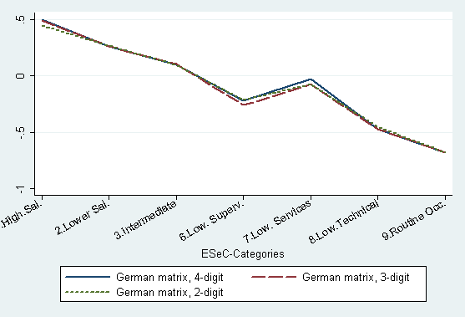 |  |  |  | 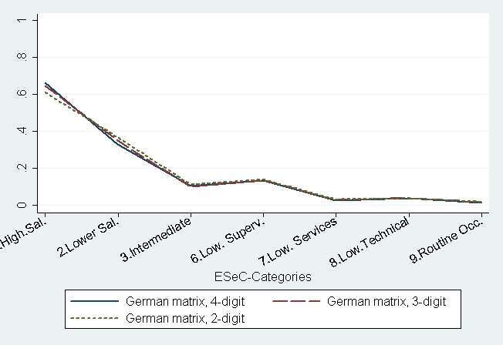
 | 2-digit | 3-digit | 4-digit |  | 2-digit | 3-digit | 4-digit
R² | 0.127 | 0.136 | 0.142 | Pseudo R | 0.234 | 0.232 | 0.251
Asset Specificity: adjusted highest degree: % requiring any degree |  |  |  | Asset Specificity: introduction to the job insufficient
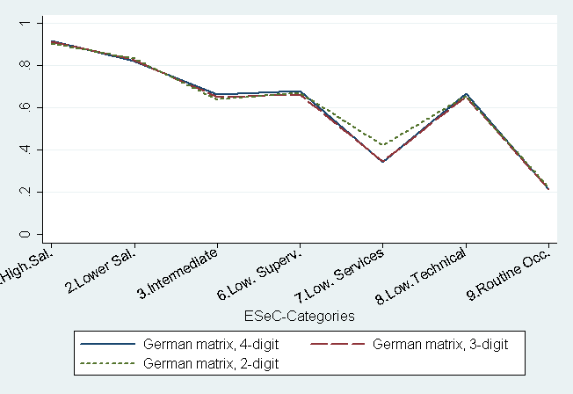 |  |  |  | 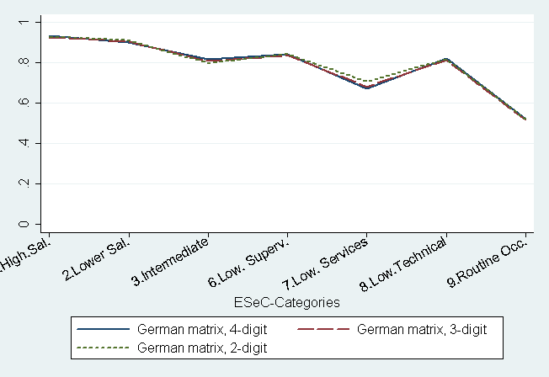
 | 2-digit | 3-digit | 4-digit |  | 2-digit | 3-digit | 4-digit
Pseudo R | 0.149 | 0.162 | 0.170 | Pseudo R | 0.091 | 0.094 | 0.098
Long-Term-Employment: Tenure Residuals |  |  |  | Career Prospects % having obtained further education
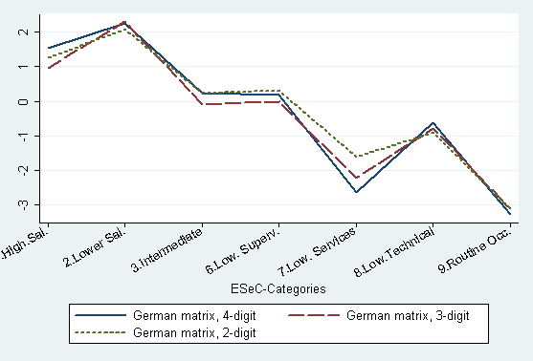 |  |  |  | 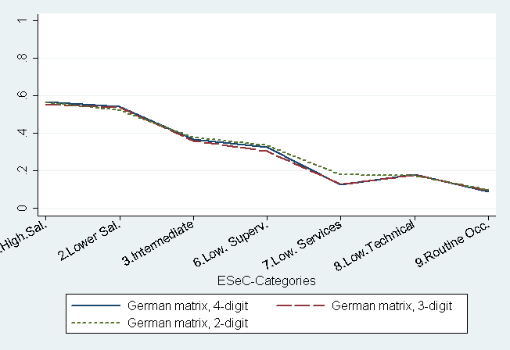
 | 2-digit | 3-digit | 4-digit |  | 2-digit | 3-digit | 4-digit
R² | 0.042 | 0.049 | 0.054 | Pseudo R | 0.101 | 0.113 | 0.118

For most ER-indicators the predicted values for class 7 are higher for the 2-digit classes than the ones given by the 4-digit and also 3-digit matrix. As described above (for details see appendix B) there are two large groups moving from class 3 to class 7, the institution-based personal care workers (5132) and the police officer employees (5162). According to the ER-indicators both OUGs belong to class 3 and the police officers have values even closer to class 1 or class 2, at least for asset specificity (“any degree”), “long-term employment” and “further education”, which explains the deviance. Furthermore, long-term-employment shows an erratic concordance since the 1st, 3rd and 6th classes are somewhat lower for the 3-digit matrix due to the movements described above. So e.g. the ‘Gymnasiallehrer’ (2321) move from class 1 to 2 which have particular high tenures.
However, even though there is a strong concordance in the class specific means of ER values with respect to the different levels of aggregation, this does not mean, that the OUG’s being moved are irrelevant to the validity of the class codes. As further analysis (not shown here) indicate the standard deviation of the ER-indicators for the different ESeC classes slightly increase from the 4-digit to the 3- and 2-digit. Thus, the classes generated from higher aggregate OUG’s are more heterogeneous in terms of ER-values. The same conclusion can be drawn from the fact, that R² becomes consistently smaller when we move from the 4- to the 3- and 2-digit classes.
2.2 Comparison of the 3- and 2-digit matrices between UK and Germany
While the former section had its main focus in the loss of information between different aggregate levels, this section investigates the correspondence of matrices within the same aggregation level but between different countries. Starting base for generating the 3-digit and 2-digit matrices were the German matrix (with some OUGs reallocated) and the German modal values. As a result these 3- and 2-digit matrices differ in some respect from the versions provided by the UK. Comparing the UK 3-digit matrix and the German 3-digit matrix 23 OUGs are assigned to different ESeC classes. As a result 12% of all observations (3.883 cases) are coded differently. The discrepancies between the 2-digit matrices are somewhat lower with about 7% (2.260) affecting 9 OUGs.
These discrepancies can have two sources: on the one hand they can be the result of different class assignments in the 4-digit matrix, on the other hand they can be the result of modal values being different for UK and Germany. To isolate these two sources three different versions of the 2-digit and 3-digit matrices have been generated:
  - Prototype V3 matrix, modal value UK
  - Prototype V3 matrix, modal value Germany
  - German matrix (with reallocations), modal value Germany
The prototype V3 is the best fitting 4-digit matrix for the UK and also the modal values derive from UK occupation distribution. So 2- and 3-digit matrices generated by this type can be interpreted as “best fitting matrices for the UK”. The 2nd type is a mixture between the UK matrix but German modal values and the last version is most adapted to German conditions.
In a first step, for each version the proportion of discrepant class codes between the different aggregate levels has been calculated. The results are shown in table 2.4. As can be seen lowest discrepancy between the different aggregate levels is provided by the prototype V3 matrix with German modal values. Here the discrepancies to the 4-digit matrix are both for the 3-digit and for the 2-digit matrix about 3% lower than for the prototype with modal values for the UK. Using the German matrix as basis ends in similar results as the prototype with UK modal value.

Table 2.4: | Proportion of discrepant class codes between different aggregate levels of ISCO in %. BIBB/IAB, 1999. (N= 33,612)
 |  | 4-digit vs. 3-digit | 4-digit vs. 2-digit
Prototype V3 matrix, modal value UK |  | 8.7 | 16.2
Prototype V3 matrix, modal value Germany |  | 5.8 | 13.1
German matrix, Modal value Germany |  | 8.2 | 15.4

At a first glance these findings are somehow surprising. However, a closer examination points to the fact, as already addressed above, that in Germany the OUGs within a minor group are more heterogeneous than for the UK. The reallocations implemented for the German 4-digit matrix have partly moved OUGs within one minor group to a different ESeC category. The OUGs which cause the main deviance are the teachers (ISCO 2321, 2322), who partly were reallocated to ESeC class 1 but end up in ESeC class 2 with the 3-digit coding. Another large group of deviant cases are the physical and engineering science technicians (311). Their modal value is ESeC 2, but about 40% of the cases of this 3-digit OUG belong to class 6 according to the 4-digit OUG. Since this is a large category, switching from 4-digit to 3-digit coding creates many discrepancies. The last OUG which creates many discrepancies are the cooks. As such they should be coded class 8, but as a result of the aggregation they end in class 9.
Thus overall, if we find that the aggregation from the 4-digit matrix to the 3-digit or 2-digit matrix produces a smaller discrepancy in class assignments for the prototype V3 matrix than for the German matrix. This is a result of the fact, that in the V3 matrix the 4-digit OUG’s within the 3- or 2-digit minor groups are more often assigned the same class code than in the German matrix. This is evidently an advantage when we aspire for identical class codes irrespective of the detail available for occupational coding. However, when we believe what the validation indicators tell us, then this has costs. The costs are, that from the very beginning (in the 4-digit codes) we allow more heterogeneity within classes. This may be more serious in some countries than in other countries. If, for the UK for instance, the 4-digit OUG’s within minor groups indeed more often belong to the same class the aggregation costs are smaller than they are e.g. for Germany.

Table 2.5 gives the proportion of discrepant class codes between the three versions but within the same aggregation level. The first row shows the discrepancies produced by using the nation specific modal values; the second row shows the discrepancies when both the matrix definitions and the model value are adapted to the German case. It seems that the application of the model value rule produces more discrepancies than the nation specific matrix definitions. Both together produce a substantial amount of discrepant class codes.

Table 2.5: | Proportion of discrepant class codes between different 4-digit matrices and modal values in %. BIBB/IAB, 1999. (N= 33,612)
 |  | 3-digit |  | 2-digit
Prototype V3 matrix, modal value UK vs.  Prototype V3 matrix, modal value Germany |  | 7.5 |  | 10.4
Prototype V3 matrix, modal value UK vs.  German matrix, Modal value Germany |  | 11.6 |  | 6.7

2.3 Conclusion
The correspondence of class codes between 4- and 3-digit versions amounts to 92% and between 4- and 2-digit to 85%. So at least for Germany it can be said that with each stage of aggregation, about 8% of discrepant class codes are generated, and the aggregation results in an increase of within-class heterogeneity. For the 3-digit matrix, classes 2 and 7 in particular are affected by such increased heterogeneity, for the 2-digit matrix this is additionally true for classes 1, 3, 7 and 8.
We further have shown that national discrepancies for the 3-digit and 2-digit matrix can be the result of a different national 4-digit matrix but also of varying modal values between the countries. It can be expected that other countries involved have also different modal values in some cases and also have own modifications of the 4-digit matrix, improving the national fit. So we want to emphasize the ambivalence that exists between on the one side having classes established in the same way in all countries; and, on the other side, having a class scheme that does justice to the national specificities. The solution for the aggregation issue indeed may be to proceed according to the modal value rule. But then it would be important to know for all countries, what the consequences of varying aggregation are in each case.
3 A comparison between ESeC and EGP
The main focus of this chapter is on the quality of the crosswalk from the German national classification of occupation 'Klassifikation der Berufe' (KldB) to ISCO-88-com by using the class schema EGP as an intermediary tool.
In most social surveys conducted in Germany the occupational information is coded according to the International Standard Classification of Occupation (Hoffmeyer-Zlotnik et al., 2004). In contrast, the standard used by official statistics is a national occupational classification known as KldB, which is adapted to the specific needs of the German labour market statistics. The KldB is based on about 30,000 occupational titles (Berufsbenennungen) which are mainly classified according to similarity in tasks into five levels of aggregation. Neither skill level nor skill specialisation are explicitly used by the KldB as classification criteria. In addition, for some official surveys (e.g. the Microcensus which includes the German Labour Force Survey), the statistical office also provides ISCO-88(com). However ISCO-88(com) is not the result of a direct occupational coding process but is produced by mapping KldB to ISCO-88(com). The mapping process is not a simple one-to-one method but involves the splitting of nationally defined occupational classes (KldB_4d) with respect to 'size of organisation' and 'status in employment' to create ISCO categories. Mapping matrices for the crosswalk KldB_4d to ISCO-88 (3-digit as well as 4-digit level) are provided by the statistical office. However, since most researchers depending on their research interest either use ISCO-88 or the KldB but hardly ever both, there is nearly no empirical knowledge which occupations might pose crosswalk problems. At the same time ESeC at least in the LFS will be based on the KldB-ISCO crosswalk.
In order to examine the implications of the crosswalk for ESeC we use EGP as an intermediary tool. We are in the fortunate position that for Germany well examined coding routines exist to generate EGP directly from KldB-3-digit data, which can also be used for ISCO data. Therefore, it is not only possible to compare the coding into EGP-classes and the coding into ESeC-classes, but also to examine the quality of the crosswalk from KldB to ISCO. Of special interest are such occupations which are coded into different EGP classes depending on which classification is used. In a second step we compare ESeC to EGP_ISCO. Besides helping to identify crosswalk problems we will be able to indicate conceptual and other reasons for differences in the allocation to EPG- and ESeC-classes. Identifying these differences and specifying the occupational areas from which they result is also important to inform the research community on the theoretical and empirical implications of using either of the two schemes of measuring social class. Finally the explanatory power of EGP_KldB, EGP_ISCO and ESeC with respect to the employment relation indicators as developed in Hausen et al. (2005) will be compared.
3.1 Data and classifications
The following analyses are based on the BIBB/IAB data. It should be mentioned, however, that the BIBB/IAB data in its original version include only the KldB_4d classification. ISCO-88(com) (4-digit and 3-digit level) was generated by using the KldB-ISCO mapping matrix provided by official statistics.
To operationalize the EGP class scheme (EGP_KldB) a well examined coding routine was used, which is orientated on the original considerations of the CASMIN researchers (Brauns et al. 2000). The coding routine is based on the KldB at the 3-digit level. Employees are allocated to EGP classes by combining occupations (KldB), employment status, and position within employment. In a first step the occupations are aggregated to 16 groups (see table A1, appendix D), which in a second step depending on employment status and position within employment are assigned to EGP classes. Compared to the employment status variable used for ESeC, the position within employment variable used for EGP is more detailed (Table 3.1), thus enabling a refined allocation of occupations to classes. The theoretical approach as well as the method to operationalize EGP is described in Brauns et al. 2000. The SPSS coding routine is documented in the internet.
Tab. 3.1 Employment status (ESeC) - Position within Employment (EGP) (without self-employed)
Position within Employment - | Employment Status - ESeC
EGP | Man>10 | Man<10 | supervisors | employees | n
Routine employee; semi-skilled worker | 1.0 | 3.3 | 7.3 | 23.1 | 5420
Employee with simple tasks; skilled worker | 1.9 | 4.3 | 16.4 | 31.8 | 7954
Employee with complex tasks ('Sachbearbeiter'); foreman | 7.6 | 9.2 | 26.0 | 25.3 | 7378
Experts ('herausgehobene qualifizierte Fachkraft'); master craftsman | 51.6 | 37.0 | 32.0 | 14.5 | 6028
head of division | 3.5 | 1.1 | 5.5 | 2.9 | 1059
head of department | 31.1 | 44.0 | 10.4 | 1.1 | 1387
director; head official | 3.4 | 1.1 | 2.5 | 1.3 | 493
n | 892 | 184 | 7654 | 20989 | 29719

We used the identical routine to create EGP_ISCO but replaced the KldB-3-digit categories by the corresponding ISCO-categories (3-digit) according to the mapping matrix provided by official statistics. Even though ISCO-4-digit is available in the BIBB/IAB data we decided to concentrate on ISCO-3-digit, simply because ISCO is included only at the 3-digit level in the Microcensus. With respect to the replacement of KldB through ISCO four different types of mapping combinations can be distinguished: '1:1'; '1:n'; 'n:1', and 'n:m' (see table 3.2). '1:n' cases are caused by the aggregation of KLdB_4d to KldB_3d. For example the KldB_4d codes '0112' '0113' and '0115' go to ISCO_4d '6111'; '6121' and '3212'. The corresponding KldB_3d '011' however is mapped to ISCO_4d '6111'; '6121' and '3212' or alternatively to ISCO_3d '611'; '612' and '321'. While '1:1' and '1:n' cases are plain sailing, in case of 'n:1' or 'n:m' allocations the modal value of the KldB categories was used to determine the ISCO code.
Tab. 3.2 Mapping KldB to ISCO for EGP-routine: Types of Combinations
KldB_3d to ISCO: | ISCO_3d | ISCO_4
Types of combinations | % (column)
1:1 | 2.1 | 5.9
1:n | 36.8 | 19.4
n:1 | 2.1 | 15.9
n:m | 59.0 | 58.9
N of different combinations | 581 | 673

3.2 EGP_ KldB compared to EGP_ISCO-88(com)
Table 3.3 displays the findings for EGP_KldB and EGP_ISCO. Looking first at the marginal distributions, the differences between the two versions are negligible. Except for one class (IIIb) all EGP-ISCO classes differ less than one percentage point from the respective EGP-KldB classes. A less high, but still considerable high agreement rate is shown by the diagonal cells. About 92 percent of all cases go to the same EGP classes, independent on the classification used. The highest agreement rate is found for VIIb followed by IVc, the lowest is found for IIIb. Only about three quarters of the cases which when using the KldB go to class IIIb are also coded to IIIb when ISCO is used, about 9 percent go to VI, another 12 percent go the VIIa/VIIb. Most of the allocations mismatched are concentrated on neighbour classes, such as the transfer between I and II or between IIIa and V. There are also some more questionable transfers, which, however, except for the combination 'II => V' represent only a few cases and are therefore negligible. In the following we will have a closer look which occupations are defined into different classes depending on the classification used.
Tab. 3.3: Correspondence between EGP_KldB(3_d) and EGP_ISCO(3_d)
EGP |  |  |  |  | ISCO(3_d)
KldB(3_d) | I | II | IIIa | IIIb | IVab | IVc | V | VI | VIIa | VIIb | % | N
I | 92.7 | 6.7 | 0.0 | 0.0 | 0.4 | 0.0 | 0.2 | 0.0 | 0.0 | 0.0 | 15.8 | 5362
II | 1.5 | 91.9 | 2.3 | 0.1 | 0.3 | 0.0 | 3.9 | 0.0 | 0.0 | 0.0 | 18.0 | 6126
IIIa | 0.3 | 2.2 | 93.3 | 1.1 | 0.0 | 0.0 | 2.6 | 0.4 | 0.1 | 0.0 | 16.1 | 5482
IIIb | 0.0 | 0.0 | 2.8 | 75.6 | 0.0 | 0.0 | 0.3 | 9.3 | 9.5 | 2.5 | 7.9 | 2682
IVab | 0.9 | 2.4 | 0.0 | 0.0 | 95.5 | 1.1 | 0.0 | 0.0 | 0.0 | 0.0 | 7.3 | 2496
IVc | 0.0 | 0.6 | 0.0 | 0.0 | 0.0 | 99.4 | 0.0 | 0.0 | 0.0 | 0.0 | 0.5 | 173
V | 0.2 | 2.6 | 2.1 | 0.0 | 0.0 | 0.0 | 93.8 | 1.1 | 0.3 | 0.0 | 7.7 | 2620
VI | 0.0 | 0.0 | 2.7 | 0.8 | 0.0 | 0.0 | 0.3 | 95.4 | 0.9 | 0.0 | 14.1 | 4800
VIIa | 0.0 | 0.0 | 0.1 | 3.7 | 0.0 | 0.0 | 0.1 | 1.4 | 94.7 | 0.0 | 11.7 | 3972
VIIb | 0.0 | 0.3 | 0.3 | 0.0 | 0.0 | 0.0 | 0.0 | 0.0 | 0.3 | 99.0 | 0.9 | 310
% | 15.0 | 18.3 | 16.2 | 6.7 | 7.1 | 0.6 | 8.4 | 14.5 | 12.0 | 1.1 | 100.0
N | 5109 | 6235 | 5527 | 2275 | 2423 | 201 | 2870 | 4936 | 4072 | 375 |  | 34023
agreement rate (diagonal cells) : 92.3% (n = 31,403)
Spearman's rho: 0.95
Source: BIBB/IAB 98/99 (bibbes_neu_234_avs.sav; classm; class_im)
I => II:
The mismatch of occupations in this group is basically due to the loss of information caused by the mapping of the more detailed KldB_3d to the less detailed ISCO_3d. For example in the KldB_3d as well as in ISCO_4d 'economists', 'sociologists' 'philosophers', 'psychologists' and 'social work professionals' are separate groups. Except for 'social work professional' all of these occupations go to class I. However in ISCO_3d these occupational groups constitute the minor group 244 'social science and related professionals', which in Germany is dominated by 'social work professionals'. Hence ISCO '244' is assigned to class II, leading to a mismatch of some professional occupations. We also face a typical crosswalk problem with respect to the upper secondary education teachers (Gymnasiallehrer), who form a separate group in the KldB and are assigned to class I. In ISCO - even at the 4-digit level - Gymnasiallehrer are coded to '2320' together with different kinds of secondary education teachers. Even though the share of Gymasiallehrer is about 27 percent in '2320', the group is dominated by other secondary education teachers and therefore go to class II.
II => IIIa
The mismatches in this group are basically caused by crosswalk problems. About three quarters of the mismatches are due to ISCO code '3419' which includes different types of 'finance and sales associates' holding different codes in the KldB_3d. Thus 'management assistants in wholesale or foreign trade’, who depending on their position within employment are coded to EGP_KldB class II, go to IIIa in EGP_ISCO because ISCO '3419' is dominated by all kind of 'retail sales occupations'.
II => V
Here the problem is mainly a result of the loss of information when using ISCO-3-digit. While in KldB_3d as well as ISCO_4d it is possible to distinguish between e.g. civil engineering technicians, electrical engineering technicians, draughtspersons, in ISCO_3d they all go to minor group '311'. As a consequence some of the occupations (e.g. draughtspersons, civil engineering technicians) which would be in EGP_KldB II, are coded to class V in EGP_ISCO.
IIIb => VI; VIIa
The mismatches are again a 3-digit problem: while 5121 (housekeepers/related workers) and 5123 (waiters etc) would go to IIIb, cooks (5122) would go to VI or VIIa (depending on their position within employment). In ISCO_3d they are all in 512 which is according to the domination rule assigned to VI (or VIIa). However there seems also to be a crosswalk problem: while hairdressers and beauticians in the KldB are separate groups and also coded to different EGP classes, ISCO_4d doesn't differentiate between these two groups, thus all go to VI (or VIIa).
IVab => II
This seems again to be a crosswalk problem. Whereas the KldB differentiates between 'image sound operators' and 'photographers' which coded to different classes if self-employed, in ISCO_4d they share one code '3131', which according to the dominance rule go to class II, if self-employed.
To sum it up, the interest of this chapter was not to discuss the allocation of specific KldB occupations to EGP classes, but only to get an idea to which extent crosswalk problems arise when the KldB_3d classification is replaced by ISCO_3d. Altogether the findings indicate a surprisingly high agreement rate. Moreover the remaining amount of mismatches is not predominantly caused by crosswalk problems but above all due to the loss of information when using ISCO_3d instead of ISCO_4d. Furthermore this result corresponds with our previous findings when replacing ISCO_4d by ISCO_3d for Operationalizing ESeC. The agreement rates found for the different ESeC versions show a similar magnitude as for the transfer from EGP_KldB to EGP_ISCO. As a consequence we will put more effort in trying to convince the German statistical office to make ISCO_4d in scientific use files available.
3.3 ESeC compared to EGP_ISCO
The next step was to compare ESeC to EGP_ISCO. Table 3.4 shows for German data as expected and as has already been shown for Swedish data by Bihagen et al. (2005) that the two class schemes are closely related. Using the same categories as the Swedish team, that is service contract (ESeC 1, 2; EGP I, II), mixed contract (ESeC 3,6; EGP IIIa, V) and labour contract (ESeC 7,8,9; EGP IIIb, VI; VIIab) it is evident that the deviations between the two schemes are concentrated within the same contract types. The most interesting 'within contract type' change happens within the higher and lower salariat. ESeC class 1 seems to be much more exclusively defined than EGP I. More than one fifth of ESeC class II are assigned to class I in the EGP scheme. Hence the total share of ESeC class 1 is only about 10 percent, in contrast, the corresponding value for EGP I is about 15 percent. However, there is also a certain amount of movement between different contract types: Thus, more than 25 percent of ESeC class 2 cases are allocated to classes IIIa and V in the EGP scheme; at the same time about 28 percent of ESeC class 3 cases go to EGP class II. The largest difference is found for ESeC class 6. Only 40 percent of the cases allocated to class 6 are assigned to the corresponding EGP class V, whereas 27 percent are allocated to EGP VI, about 15 percent go to VIIab and another 8 percent to class II.
Tab. 3.4: Correspondence between ESeC(3_d) and EGP_ISCO(3_d) (row %)
 |  |  |  |  |  | EGP ISCO_3d
ESeC |  | Service contract |  | Mixed contract |  | Labour Contract |  |  | Self employed
ISCO(3_d) |  | I | II | IIIa | V | IIIb | VI | VIIab | IVab | IVc | % | N
service | 1 higher salariat | 86.4 | 5.1 | 0.0 | 0.6 | 0.0 | 0.0 | 0.0 | 4.4 | 3.5 | 10.5 | 3525
contract | 2 lower salariat | 21.8 | 47.9 | 17.4 | 8.9 | 1.6 | 1.6 | 0.0 | 0.7 | 0.0 | 25.2 | 8476
mixed | 3 intermed. occup. | 0.5 | 27.8 | 62.3 | 0.0 | 6.4 | 3.0 | 0.0 | 0.0 | 0.0 | 16.2 | 5434
contract | 6 lower supervisor | 0.1 | 8.0 | 3.0 | 40.4 | 6.2 | 26.9 | 15.5 | 0.0 | 0.0 | 9.1 | 3068
labour | 7 lower service | 0.0 | 1.6 | 14.4 | 5.7 | 52.4 | 13.9 | 12.1 | 0.0 | 0.0 | 7.6 | 2569
contract | 8 lower technical | 0.0 | 0.2 | 0.0 | 12.6 | 0.0 | 63.9 | 23.2 | 0.0 | 0.0 | 12.3 | 4120
 | 9 routine occup | 0.0 | 0.3 | 2.4 | 4.7 | 6.0 | 19.0 | 67.6 | 0.0 | 0.0 | 11.5 | 3868
self | 4 s.e. excl agric | 6.0 | 4.7 | 0.0 | 0.0 | 0.0 | 0.0 | 0.0 | 89.3 | 0.0 | 7.3 | 2467
employed | 5 s.e. agric. | 0.0 | 0.0 | 0.0 | 0.0 | 0.0 | 0.0 | 0.0 | 0.0 | 100.0 | 0.2 | 78
% |  | 15.1 | 18.4 | 16.1 | 8.5 | 6.7 | 14.4 | 13.0 | 7.2 | 0.6 | 100.0
N |  | 5075 | 6170 | 5422 | 2859 | 2250 | 4848 | 4360 | 2420 | 201 |  | 33605
agreement rate (diagonal cells) : 61,3% (n = 20,606)
Spearman's rho: 0.85
Source: BIBB/IAB 98/99 (bibbes_neu_234_avs_egp.sav; class_im; ESeC3neu)
Note: EGP classes IIIb; V; IVab; IVc were switched to have ESeC comparable categories in the diagonals. Same contract types (service; mixed, labour) are indicated by shaded cells.

The deviations between ESeC and EGP_ISCO as just described could be caused by at least three different factors: (1) crosswalk problems. However, as has been shown in the previous chapter by comparing EGP_KldB and EGP_ISCO the crosswalk is not a major difficulty and therefore couldn't be the main cause for the deviations observed between ESeC and EGP_ISCO. (2) different allocations of occupations to class positions due to conceptual reasons; (3) different allocations of occupations to class positions due to differences in the employment status variable used for operationalizing the two class schemes. In a next step we explore the deviations further by looking at a subset of 'between contract type movers' depending on the occupation. In order to differentiate between rather conceptual or rather employment status effects the stayers for the classes of interest are also shown. For the sake of clarity Table 3.5 displays only ISCO sub-major groups, while our reasoning actually is based on the analysis of the corresponding minor groups.
According to the findings presented in Table 3.5 the movements between contract types seems mainly to be caused by the differences in the 'employment status' variables used for operationalising EGP and ESeC. Whereas the employment status variable used for ESeC only distinguishes between managers (> 10; < 10 employees), supervisors and employees, the 'status within employment' variable used for EGP offers seven categories (see Table 3.1), thus enabling a more differentiated assigning of occupations to classes. This is indicated by the combination of movers and stayers for one and the same minor group, which can be only due to employment status. Take for example the movements between ESeC class 2 to EGP IIIa which are to a large extent due to the sub-major groups ‘34’ (other associate professionals) and ‘41’ (office clerks). However the same minor groups hold a considerable amount of stayers with respect to ESeC class 2. At the same time the movements between ESeC 3 and EGP II are also mainly due to the sub-major groups '34' and '41' and again the movers come along with an even higher amount of stayers. A similar pattern can be found for nearly all other sub-major groups. However with respect to ISCO-code 12 ('corporate managers') the switches between ESeC class 2 to EGP V seem to be a crosswalk problem. This group of movers are master-workmen (Werkmeister) who go to ISCO manager group '1222' and thus are assigned to ESeC 2 (alternatively 1 or 4). In the German context master-workmen are as a rule assigned to EGP class V, only if their position within employment is head of division, head of department, or head official, they go either to EGP class II or I.
Tab. 3.5:'Between contract type movers': ESeC_3d - EGP_ISCO compared
 |  | ESeC 2 |  |  | ESeC 3 |  | ESeC 6 |  |  |  | ESeC 7 |  | ESeC 8
 | EGP: | II | IIIa | V | IIIa | II | V | II | VI | VII | IIIb | IIIa | VI | V
 | ISCO sub-major groups | S¹⁾ | M²⁾ | M | S | M | S | M | M | M | S | M | S | M
01 | Armed forces | 30 | 55 |  | 13 | 2
12 | Corporate managers | 16 |  | 175
13 | Managers of small enterprises | 52 | 15
31 | Physical and engineering science associate professionals | 399 |  | 578 |  |  | 33 | 44 | 25 | 37
32 | Life science and health associate professionals | 1040 | 5 |  |  |  |  | 98
33 | Teaching associate professionals | 209 | 40 |  | 215 | 132
34 | Other associate professionals | 541 | 931 |  | 1199 | 488
41 | Office clerks | 499 | 308 |  | 1497 | 766 |  | 8
42 | Customer services clerks | 17 | 55 |  |  |  |  |  |  |  | 199 | 160
51 | Personal and protective services workers | 94 | 70 |  | 464 | 120 | 130 | 21 | 81 | 42 | 14 | 11
52 | Models, salespersons and demonstrators |  |  |  |  |  |  | 16 |  |  | 1133 | 194
61 | Skilled agricultural and fishery workers |  |  |  |  |  | 33 | 6 |  | 48 |  |  |  | 41
71 | Extraction and building trades workers |  |  |  |  |  | 359 | 14 | 274 | 40 |  |  | 1058 | 132
72 | Metal, machinery and related trades workers |  |  |  |  |  | 290 | 20 | 205 | 23 |  |  | 1133 | 186
73 | Precision, handicraft, craft printing and related trades workers |  |  |  |  |  | 100 | 4 | 72 | 16 |  |  | 66 | 38
74 | Other craft and related trades workers |  |  |  |  |  | 87 | 5 | 66 | 14 |  |  | 351 | 64
81 | Stationary plant and related operators |  |  |  |  |  | 39 | 2 | 14 | 24 |  |  |  | 6
82 | Machine operators and assemblers |  |  |  |  |  | 48 | 1 | 39 | 51 |  |  | 6 | 2
83 | Drivers and mobile plant operators |  |  |  |  |  | 63 | 3 | 31 | 34 |  |  | 20 | 50
91 | Sales and services elementary occupations |  |  |  |  |  | 32 | 3 | 18 | 51 | 1 | 4
92 | Agricultural, fishery and related labourers |  |  |  |  |  | 3 |  |  | 4
93 | Labourers in mining, construction, manufacturing and transport |  |  |  |  |  | 22 |  |  | 91
ESeC3neu ESeC, neue Matrix 3digit ohne SC; cl_im; bibbes_neu234_avs_egp.sav
1) S = Stayers (ESeC class corresponds EGP class)
2) M = Movers (between contract types)
3.4 Employment relation indicators: Explanatory power of ESeC and EGP
Given that the deviations between ESeC and EGP_ISCO are to a great extent a result of the employment status variables used for assigning occupations to classes, the next question is, whether the explanatory power differs between the two schemes. For this comparison we draw on the four employment relation indicators 'work autonomy', 'asset specificity' (requiring foreman education/college; requiring any degree; only introduction to job not sufficient), 'long-term employment', 'career prospects' already described in section 1.2. Furthermore we include EGP_KldB as reference classification. Results are given in Figure 3.1 to 3.6 (excluding workers in self-employment).
Work autonomy (Figure 3.1)
Looking at the class specific work autonomy values as displayed in Figure 3.1 it is evident, that EGP_KldB and EGP_ISCO are almost identical and at large in agreement with the findings from ESeC. However, in contrast to ESeC, in EGP lower supervisors (V) as well as lower technicals (VI) yield higher scores than the corresponding ESeC classes (6; 8). Hence the class specific autonomy pattern is in the EGP scheme more linear than in ESeC: The autonomy scores of lower supervisors (V/6) are now much closer to the holders of intermediate occupations (3/IIIa) and somewhat more in contrast to EGP VIIab (ESeC 9).
Asset specificity (Figure 3.2 to 3.4)
While there is no substantial difference between ESeC and EGP with respect to the work autonomy indicator, when it comes to the different asset specificity indicators the explanatory power (measured by McFadden Pseudo-R²) of both EGP versions is notably higher than of ESeC. Moreover all three indicators discriminate more clearly and in a theoretical more consistent way between EGP classes than between ESeC classes (Figure 3.2 to 3.4). This is mainly due to the lower supervisors (EGP V) which in the EGP scheme have a distinctly higher extent of asset specificity. Consequently the extent of asset specificity for EGP V is now closer to the lower salariat and shows a stronger contrast to the intermediate occupations as well as to the lower service occupations and the routine occupations.
Long term employment and career prospects (Figure 3.5 to 3.6)
Given the fact that in Germany still most work contracts are permanent, the indicator 'long term employment' is not expected to show strong contrasts between different classes. Nevertheless the pattern found for ESeC with the lower salariat showing a higher tenure than the higher salariat is theoretically not consistent. As described in Hausen et al. (2005: 24) we assume that this might result from specific conditions of employment for particular groups of workers in class 2. In favour of this hypothesis are the findings for the EGP scheme as displayed in Figure 3.5. In line with the theoretical expectation the tenure for EGP class I shows a distinct higher value than for class II.
A similar pattern though less distinct is found for the career prospects indicator (Figure 3.6). Again EGP class I has to some extent more promising career prospects than class II, whereas the corresponding ESeC classes show no differences.
Figure 3.1 to 3.6: Employment Relation Indicators EGP und ER-Indicatoren

Fig. 3.1: Work Autonomy, Means of Factor Scores, (BIBB/IAB) |  |  |  | Fig. 3.2: Asset Specificity: adjusted highest degree: % requiring foreman education/college (BIBB/IAB)
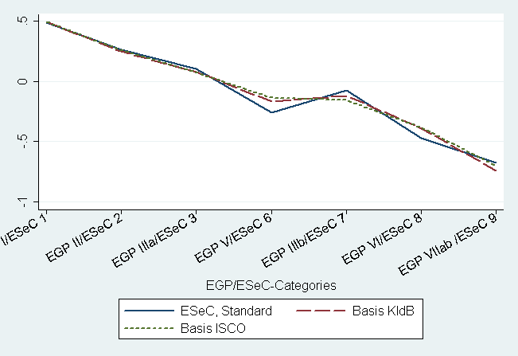 |  |  |  | 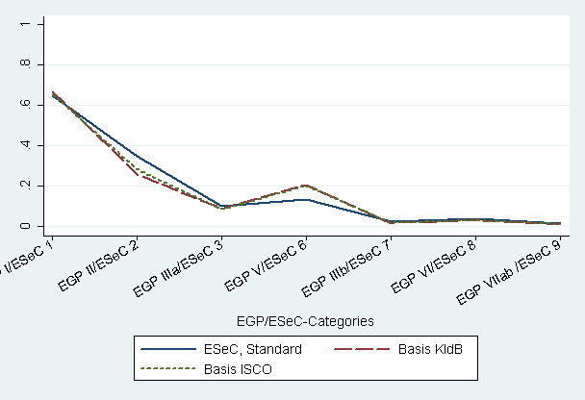
 | EGP_KldB | EGP_ISCO | ESeC_3d |  | EGP_KldB | EGP_ISCO | ESeC_3d
R² | 0.151 | 0.145 | 0.137 | Pseudo R | 0.294 | 0.288 | 0.232
Fig. 3.3: Asset Specificity: adjusted highest degree: % requiring any degree (BIBB/IAB) |  |  |  | Fig. 3.4: Asset Specificity: only introduction to the job not sufficient (BIBB/IAB)
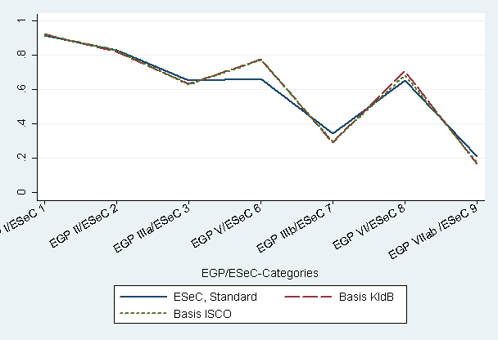 |  |  |  | 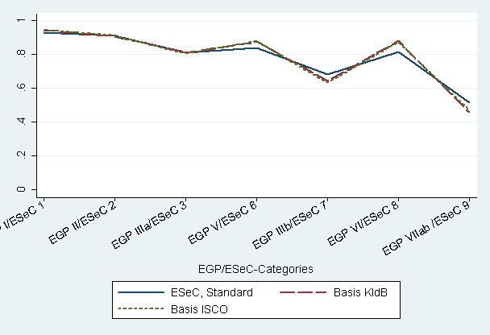
 | EGP_KldB | EGP_ISCO | ESeC_3d |  | EGP_KldB | EGP_ISCO | ESeC_3d
Pseudo R | 0.214 | 0.206 | 0.162 | Pseudo R | 0.143 | 0.139 | 0.094
Fig. 3.5: Long-Term-Employment: Tenure Residuals, BIBB/IAB |  |  |  | Fig. 3.6: Career Prospects % having obtained further education (BIBB/IAB)
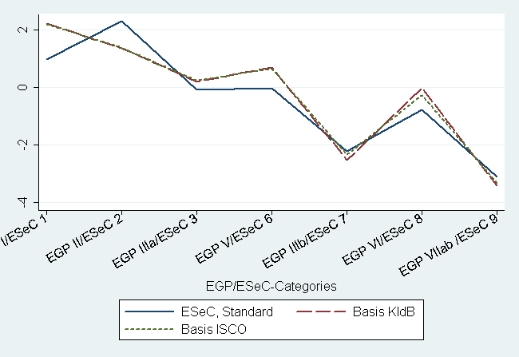 |  |  |  | 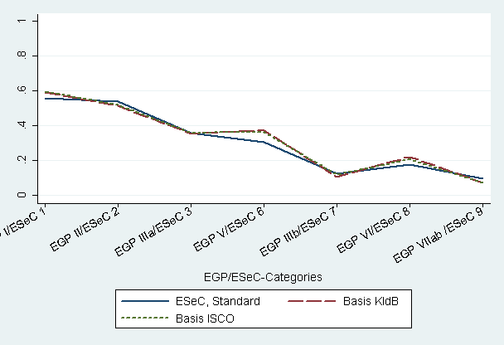
 | EGP_KldB | EGP_ISCO | ESeC_3d |  | EGP_KldB | EGP_ISCO | ESeC_3d
R² | 0.050 | 0.047 | 0.049 | Pseudo R | 0.123 | 0.122 | 0.113
The primary purpose of the comparison of ESeC and EGP was to identify crosswalk problems in the mapping of the KldB to ISCO. The results presented indicate that crosswalk problems seem to be restricted to specific occupational groups such as upper secondary teachers or master-workmen. The divergence we observed between both class schemes according to which the empirical results for EGP are to some extent more theoretically consistent than for ESeC are not resulting from crosswalk problems. In fact the rather rough employment status variable used for ESeC seems to effect the deviation in the allocation of occupations to classes. On the one hand it is evident that for the sake of international comparability the employment status variable must be kept simple. On the other hand it seems that the differentiation between managers, supervisors and employees is not only a specific German problem. At least in our opinion, this problem can not easily be solved by asking just another question. The reason for this is that the differentiation between managers, supervisors and employees is rather uncommon in the German context and we can not take for granted that the majority of the respondents actually know to which category they belong. To be sure, we do not suggest using a totally different employment status variable, but we are highly interested to know how this variable has been operationalized by the other teams. Moreover it would be helpful to know if and how the supervisor question is actually asked in the different countries as well as whether there is a national version to measure the employment status.
4 Class effects on risks of unemployment
This section includes some analysis on a substantive topic to explore how the different variants of EGP and ESeC affect estimates of class effects on the risk of unemployment. In relation to the issues discussed in the former sections there are three aspects we want to discuss: (1) a comparison of the prototype and the German matrix, (2) the effect of different levels of aggregation, and (3) EGP compared to ESeC. In order to carry out these comparisons we are bound to the BIBB/IAB data. This leads to some restrictions in the analysis, the most important ones being, that the design of the data is cross-sectional and that the sample only includes respondents who were employed at the date of survey.
Therefore, our dependent variable is the odds of having been registered unemployed in the past for at least once. Besides class the list of predictors includes age, gender, citizenship, education (measured in CASMIN codes), a dummy for residence in East Germany and a dummy for part-time workers. The resulting odds are presented in table 4.1. The first three columns present the findings for the UK matrix (4-digit, 3-digit, 2-digit), the next three columns show the corresponding findings for the German matrix, in the last two columns the results for EGP_KldB and EGP_ISCO are shown.

Table 4.1 :Logistic regression of the odds of having been unemployed in the past for at least once BIBB/IAB
(N= 33.433)
 | ESeC |  |  |  |  |  | EGP
 | UK Matrix (Prototype, V3) + UK-modal value |  |  | German Matrix +  German modal value |  |  | Basis  KldB | Basis  ISCO
 | 4-digit | 3-digit | 2-digit | 4-digit | 3-digit | 2-digit | 3-digit | 3-digit
Age | 1.18*** | 1.18*** | 1.17*** | 1.18*** | 1.18*** | 1.18*** | 1.17*** | 1.17***
Age² | 1.00*** | 1.00*** | 1.00*** | 1.00*** | 1.00*** | 1.00*** | 1.00*** | 1.00***
Female | 0.98 | 0.99 | 1.00 | 0.96 | 0.98 | 0.98 | 0.93* | 0.93*
German Citizenship | 1.10 | 1.10 | 1.09 | 1.1 | 1.09 | 1.09 | 1.15* | 1.13*
CASMIN (ref. 3b)
1a | 1.30* | 1.33* | 1.41** | 1.21 | 1.29* | 1.35** | 1.06 | 1.11
1b | 1.37*** | 1.40*** | 1.49*** | 1.27*** | 1.36*** | 1.42*** | 1.15* | 1.22**
1c | 1.20*** | 1.21*** | 1.28*** | 1.12* | 1.18** | 1.22*** | 1.15** | 1.19**
2a | 1.04 | 1.05 | 1.09 | 0.99 | 1.03 | 1.04 | 1.01 | 1.03
2b | 1.18 | 1.21 | 1.27* | 1.11 | 1.17 | 1.21 | 1.08 | 1.11
2c_gen | 0.48*** | 0.49*** | 0.51*** | 0.46*** | 0.48*** | 0.49*** | 0.45*** | 0.46***
2c_voc | 1.21*** | 1.22*** | 1.24*** | 1.16* | 1.19** | 1.20** | 1.17** | 1.19**
3a | 1.27*** | 1.27*** | 1.28*** | 1.23*** | 1.25*** | 1.26*** | 1.23** | 1.24***
East Germany | 2.09*** | 2.08*** | 2.11*** | 2.06*** | 2.08*** | 2.10*** | 2.10*** | 2.11***
Part-time | 0.73*** | 0.72*** | 0.72*** | 0.74*** | 0.73*** | 0.72*** | 0.74*** | 0.73***
ESeC / EGP
1 / i | 0.42*** | 0.44*** | 0.48*** | 0.39*** | 0.44*** | 0.43*** | 0.34*** | 0.36***
2 / ii | 0.49*** | 0.48*** | 0.51*** | 0.45*** | 0.46*** | 0.49*** | 0.42*** | 0.44***
3 / iiia | 0.57*** | 0.59*** | 0.61*** | 0.56*** | 0.61*** | 0.61*** | 0.48*** | 0.51***
4 / ivab | 0.57*** | 0.57*** | 0.58*** | 0.55*** | 0.57*** | 0.58*** | 0.47*** | 0.48***
5 / ivc | 0.51* | 0.51* | 0.51* | 0.50* | 0.51* | 0.51* | 0.23*** | 0.27***
6 / v | 0.61*** | 0.64*** | 0.60*** | 0.59*** | 0.63*** | 0.60*** | 0.46*** | 0.48***
7 / iiib | 0.68*** | 0.63*** | 0.62*** | 0.73*** | 0.68*** | 0.63*** | 0.61*** | 0.61***
8 / vi | 0.74*** | 0.76*** | 0.76*** | 0.69*** | 0.75*** | 0.76*** | 0.47*** | 0.52***
Constant | 0.03*** | 0.03*** | 0.03*** | 0.04*** | 0.04*** | 0.03*** | 0.05*** | 0.04***
Pseudo R² | 0.044 | 0.044 | 0.043 | 0.045 | 0.044 | 0.044 | 0.048 | 0.047

The control variables are relatively constant over the different levels of aggregation and ESeC versions and show the expected effects except for gender and citizenship. Women show a persistently lower risk of having been registered unemployed while respondents with German citizenship have a higher risk compared to foreigners. These unexpected results may be due to the selective nature of the sample. Furthermore, women may move into inactivity (for maternity or other reasons) and not register at the labour office. Foreigners may not register for unemployment because they run the risk of loosing the permission to stay in the country.
Turning to the class effects, a clear hierarchy can be seen regarding the risk of having been registered unemployed in the past. The higher salariat occupations (1) have the lowest risk which is less than the half of one for the routine occupations, followed by the lower salariat occupations (2), self-employed in agriculture (5), non-professional self-employed (4) and intermediate occupations (3), and the lower supervisory (6), services (7) and technical (8) occupations. Finally, the routine occupations, defined as reference, have the highest risk of having been unemployed. This order is nearly constant for all versions. The R² values for the different variants do not differ much either, except that variance explained by the EGP classes is slightly larger than for ESeC classes.
However, in terms of effect size, some distinct pattern appears when we consider figure 4.1 which displays the class effects. First, for the EGP-classes the contrast in unemployment risks between the reference class VIIab and all other classes is consistently larger than for the ESeC classes. Second, the EGP farmers appear to have a much lower unemployment risk than the ESeC farmers. Third, while the results for ESeC suggest a remarkable higher ‘unemployment risk’ for the lower technical occupations (7) than for the lower services class (8), the findings for EGP indicate quite the opposite. As a consequence IIIb and VIIab are the EGP classes with the highest unemployment risk, whereas when using the ESeC scheme, the holders of lower technical or routine occupations (ESeC 7, 8) have the highest unemployment risk.
The fact that the two EGP versions hardly differ from each other is consistent with our previous conclusion that the crosswalk from KldB to ISCO does not cause major problems. The remarkable lower risk of unemployment for the EGP farmers compared to ESeC farmers is due to operational / conceptual differences. Whereas in the ESeC scheme farm holders with at least one employee go to class I, in the EGP scheme they go to EGP IVc. Hence the likely better off farmers in IVc – those who employ labour - must have experienced much less unemployment in the past than the agricultural smallholders who are the only farmers allocated to ESeC class 5. The other differences between the EGP-effects and the ESeC effects most likely result from differences in the coding of EGP VI and VIIab, and their ESeC equivalents. EGP VIIab more homogeneously (than ESeC 9) includes OUG’s which have higher unemployment risks. This is why basically all other EGP classes differ more from the reference class VIIab than the ESeC classes from the reference ESeC class 9. At the same time EGP VI includes fewer cases with high unemployment risks. That is why the unemployment risks of EGP VI workers are considerably smaller than those of ESeC 8 workers.
Among the ESeC versions the German 4-digit version produces results that are most similar to the EGP classes. For this ESeC version, the contrasts of the various classes to the reference class are largest and the pattern of effects comes closest to the EGP-effects. Similarly as EGP class IIIb ESeC 7 is closest to the reference class. The higher unemployment risk of the German 4-digit class 7 (compared to the other ESeC versions) is due to the reallocation of cashiers (4211) and waiters (5123) to ESeC 7 (cases which become ESeC 3 and 9 when coding from 3- and 2-level ISCO).
For both the prototype and the German version class coding from 3- or 2 digit OUG’s results in slightly smaller class effects, but the differences to 4-digit coding are not very large.
A further interesting finding results when examining more closely the education effects (see figure 4.2). Except for the 2c-gen education group (which to a large extent includes working students who hardly can be registered unemployed) the risk of having experienced unemployment in the past does not vary strongly by level and type of education, once social class is controlled. The risks of education are somewhat larger for those with little education than for the 3b - (university degree) reference group. But the most interesting finding is that the different versions of class coding eat up to a different extent the higher risks of unemployment among those with low qualifications. The smallest effects of education remain with EGP class codes, followed by the German ESeC version. The effects of education remain highest with the prototype ESeC. The higher the aggregation of ISCO used for class coding, the less specific class measures will be, but the more pronounced are the effects of education which remain when the class positions are controlled to which different levels and types of education provide access to.
To put it in other words: When we think that risks of unemployment are tied to the nature of jobs or class positions then we should be interested in an instrument to assess class position that as clearly as possible relates the risks of unemployment to the structure of classes. In that case the EGP classes would be most appropriate. Education would still play its role, as it mediates access to class positions, but the institution in which varying risks of unemployment are generated is the organisation of jobs in the class structure. If, however, someone wants to provide evidence, that it is basically human capital that does it, he might prefer a class scheme that leaves a lot of room for direct effects of education.
The results of this example using class as a variable in substantive research may be read in different ways. On the one side, one may conclude that the different versions of ESeC coding return basically similar findings. R² and the size and pattern of ESeC class effects do not differ much and basically tell the same story. However, having in mind that all the variation between the different lines in the figures 4.1 and 4.2 derive from absolutely identical initial information, it is quite disturbing, how different the conclusions one may draw could be. The size of class effects on risks of unemployment varies depending on the procedure used to generate class codes; the relative position of some of the classes with respect to these risks varies as well, and the role assigned to education also varies systematically depending on the procedure used.
References
Hillmert, S. (2001). Ausbildungssysteme und Arbeitsmarkt: Lebensverläufe in Großbritannien und Deutschland im Kohortenvergleich (Studien zur Sozialwissenschaft, Vol. 212). Wiesbaden
Gangl, M. (2003). Unemployment dynamics in the United States and West Germany: economic restructuring, institutions and labour market processes. Heidelberg
Hall, Peter and Soskice, David (2001). Varieties of Capitalism. The Institutional Foundations of Comparative Advantage.
Streek, Wolfgang (1997). The German Economic Model: Does it Exist? Can it Survive? In: Colin Crouch and Wolfgang Streek: Political Economy of Modern Capitalism: Mapping Convergence and Diversity. London: Sage, pp. 33-54.
(Goldthorpe, J.H. (2000). On Sociology (Chapter 10). Oxford.
(Goldthorpe, J.H., Abigail McKnight (2003). The Economic Basis of Social Class. Conference on ‘Frontiers of Social and Economic Mobility’. Center for the Study of Social Inequality, Cornell University, March 27-29, 2003.
Kim, Anna, und Karin Kurz (2003): Prekäre Beschäftigung im Vereinigten Königreich und Deutschland. Welche Rolle spielen unterschiedliche institutionelle Kontexte?. S. 167-197 in: Müller, Walter; Scherer, Stefani (Eds.): Mehr Risiken - mehr Ungleichheit? Abbau des Wohlfahrtsstaates, Flexibilisierung der Arbeit und die Folgen. Frankfurt: Campus.
Appendix A
Movements from class 9 to class 7, 8
ISCO |  | 4-digit | 3-digit | Obs. | Percent | Cum.
5122 | Cooks | 9 | 7 | 253 | 47.9 | 47.9
7129 | Building frame and related trades workers not elsewhere classified | 9 | 8 | 56 | 10.6 | 57.1

Movements from class 1 to class 2
ISCO |  | 4-digit | 3-digit | Obs. | Percent | Cum.
2321 | Upper secondary education teachers at Gymnasium | 1 | 2 | 259 | 44.3 | 44.3
2441 | Economists | 1 | 2 | 107 | 18.3 | 62.6

Movements from class 6 to 2
ISCO |  | 4-digit | 3-digit | Obs. | Percent | Cum.
3118 | Draughtspersons | 6 | 2 | 112 | 19.9 | 19.9
3111 | Chemical and physical science technicians | 6 | 2 | 94 | 16.7 | 36.7
3114 | Electronics and telecommunications engineering technicians | 6 | 2 | 71 | 12.6 | 49.3
4131 | Stock clerks | 6 | 2 | 68 | 12.1 | 61.4

Movements from class 7 to 3
ISCO |  | 4-digit | 3-digit | Obs. | Percent | Cum.
4131 | Stock clerks | 7 | 3 | 132 | 42.9 | 42.9
5139 | Personal care and related workers not elsewhere classified | 7 | 3 | 44 | 14.3 | 57.2
5169 | Protective services workers not elsewhere classified | 7 | 3 | 38 | 12.3 | 69.5

Appendix B

Movements from class 1 to class 2
ISCO |  | 4-digit | 2-digit | Obs. | Percent | Cum.
2321 | Upper secondary education teachers at Gymnasium | 1 | 2 | 259 | 37.5 | 37.5
2310 | College, university and higher education teaching professionals | 1 | 2 | 147 | 21.3 | 58.8
2419 | Business professionals not elsewhere classified | 1 | 2 | 97 | 14.0 | 72.8

Movements from class 2 to class 1
ISCO |  | 4-digit | 2-digit | Obs. | Percent | Cum.
3449 | Customs, tax and related government associate professionals nes | 2 | 1 | 505 | 39.1 | 39.1
1222 | Production and operations managers in manufacturing | 2 | 1 | 157 | 12.2 | 51.3
1233 | Sales and marketing managers | 2 | 1 | 152 | 11.8 | 63.1

Movements from class 6 to 2
ISCO |  | 4-digit | 2-digit | Obs. | Percent | Cum.
3118 | Draughtspersons | 6 | 2 | 112 | 15.1 | 15.1
3152 | Building and fire inspectors | 6 | 2 | 96 | 12.9 | 28.0
3111 | Chemical and physical science technicians | 6 | 2 | 94 | 12.7 | 40.7
3211 | Life science technicians | 6 | 2 | 93 | 12.5 | 53.2
3114 | Electronics and telecommunications engineering technicians | 6 | 2 | 71 | 9.6 | 62.8

Movements from class 3 to 7
ISCO |  | 4-digit | 2-digit | Obs. | Percent | Cum.
5132 | Institution-based personal care workers | 3 | 7 | 445 | 57.5 | 57.5
5162 | Police officers | 3 | 7 | 137 | 17.7 | 75.2

Movements from class 9 to class 7, 8
ISCO |  | 4-digit | 2-digit | Obs. | Percent | Cum.
5122 | Cooks | 9 | 7 | 253 | 47.9 | 47.9
7129 | Building frame and related trades workers not elsewhere classified | 9 | 8 | 56 | 10.6 | 58.5
7143 | Building structure cleaners | 9 | 8 | 47 | 8.9 | 67.4

Appendix C: ESeC matrix for the 2- and 3-digit ISCO for Germany with discrepancies to the aggregated matrices provided by the UK
Number of affected observations in parenthesis, UK value in the last column.
3-DIGIT Germany
ISCO | SE  10+ | SE  <10 | SE  NO | MAN  10+ | MAN  <10 | SUP | EMP | Simpl.  Class | Comment
123 | 1 | 4 | 4 | 2 (222) | 2 | IC | IC | 1 | RA (UK 1)
243 | 1 | 2 | 1 | IC | IC | 1 (30) | 2 | 2 | RA (UK 2)
246 | 1 | 2 | 2 | IC | IC | 1 (36) | 2 | 1 | RA (UK 2)
247 | IC | IC | IC | IC | IC | 1 | 2 (197) | 1 | RA (UK 1)
315 | 1 | 2 | 2 | IC | IC | 2 | 6 (99) | 6 | RA (UK 2)
321 | 1 | 2 | 2 | IC | IC | 2 | 6 (103) | 6 | RA (UK 2)
334 | 1 | 4 | 4 | IC | IC | 2 | 2 (72) | 2 | RA (UK 7)
341 | 1 | 4 (69) | 4 | IC | IC | 2 | 3 | 3 | DM + RA (UK 2)
342 | 1 | 4 (25) | 4 (50) | IC | IC | 2 | 3 (102) | 3 | RA (UK 2,2,2)
346 | 1 | 2 | 2 | IC | IC | 2 | 3 (230) | 3 | RA (UK 2)
347 | 1 | 4 | 4 | IC | IC | 2 | 3 | 4 | DM
413 | 1 | 4 | 4 | IC | IC | 2 (205) | 3 (366) | 3 | DM (UK 6,7)
414 | 1 | 4 | 4 | IC | IC | 6 (20) | 9 | 9 | DM (UK 2)
421 | 1 | 4 | 4 | IC | IC | 2 | 7 (253) | 7 | RA (UK 3)
512 | 1 | 4 | 4 | IC | IC | 6 | 7 (579) | 7 | DM + RA (UK 9)
513 | 1 | 4 | 4 | IC | IC | 2 (95) | 3 (539) | 3 | 2: DM (UK 6)  3: RA (UK 7)
516 | 3 | 3 | 3 | IC | IC | 2 | 3 | 2 | DM
610 | 1 | 1 | 5 | IC | IC | 6 | 8 | 1 | DM
615 | 1 | 1 | 5 | IC | IC | 6 | 8 | 8 | DM
712 | 1 | 4 | 4 | IC | IC | 6 | 8 | 8 | DM
724 | 1 | 4 | 4 | IC | IC | 6 | 8 (288) | 8 | DM+RA ( UK 6)
743 | 1 | 4 | 4 | IC | IC | 6 | 8 (151) | 8 | DM (UK 9)
812 | 1 | 4 | 4 | IC | IC | 6 | 9 (50) | 9 | DM + RA (UK 8)
815 | 1 | 4 | 4 | IC | IC | 6 | 9 (97) | 9 | DM (UK 8)
RA = Result of Reallocations in the 4-digit Matrix
DM = Different Modal Value in Germany

2-DIGIT Germany
ISCO | SE  10+ | SE  <10 | SE  NO | MAN  10+ | MAN  <10 | SUP | EMP | Simpl.  Class
11 | 1 | 1 | 1 | 1 | 1 | 2 (97) | 3 (20) | 2 | DM (UK 1,1)
23 | 1 | 2 | 2 | IC | IC | 2 (242) | 2 | 2 | DM + RA (UK 1)
24 | 1 | 1 | 1 | IC | IC | 1 | 2 (791) | 1 | RA (UK 1)
31 | 1 | 2 (34) | 2 (57) | IC | IC | 2 | 2 | 2 | DM (UK 4,4)
33 | 1 | 4 | 4 | IC | IC | 2 | 3 (419) | 3 | DM (UK 7)
42 | 1 | 4 | 4 | IC | IC | 2 | 7 (379) | 7 | RA (UK 3)
61 | 1 | 1 | 5 | IC | IC | 6 | 8 | 8 | DM
71 | 1 | 4 | 4 | IC | IC | 6 | 8 | 8 | DM
73 | 1 | 4 | 4 | IC | IC | 6 | 8 | 6 | DM
81 | 1 | 4 | 4 | IC | IC | 6 | 9 (221) | 9 | RA (UK 8)
RA = Result of Reallocations in the 4-digit Matrix
DM = Different Modal Value in Germany

Appendix D
Tab. A1: Correspondence between ESeC(3_d) and EGP_ISCO(3_d) (column %)
ESeC |  |  |  |  | EGP ISCO_3d
ISCO(3_d) | I | II | IIIa | V | IIIb | VI | VIIab | IVab | IVc | % | N
1 higher salariat | 60.0 | 2.9 | 0.0 | 0.7 | 0.0 | 0.0 | 0.0 | 6.4 | 61.2 | 10.5 | 3525
2 lower salariat | 36.5 | 65.8 | 27.3 | 26.3 | 6.0 | 2.8 | 0.1 | 2.5 | 0.0 | 25.2 | 8476
3 intermed. occup. | 0.5 | 24.4 | 62.5 | 0.0 | 15.4 | 3.4 | 0.0 | 0.1 | 0.0 | 16.2 | 5434
6 lower supervisor | 0.1 | 4.0 | 1.7 | 43.3 | 8.4 | 17.0 | 10.9 | 0.0 | 0.0 | 9.1 | 3068
7 lower service | 0.0 | 0.6 | 6.8 | 5.1 | 59.9 | 7.3 | 7.1 | 0.0 | 0.0 | 7.6 | 2569
8 lower technical | 0.0 | 0.1 | 0.0 | 18.2 | 0.0 | 54.3 | 21.9 | 0.0 | 0.0 | 12.3 | 4120
9 routine occup | 0.0 | 0.2 | 1.7 | 6.3 | 10.3 | 15.2 | 60.0 | 0.0 | 0.0 | 11.5 | 3868
4 s.e. excl agric | 2.9 | 1.9 | 0.0 | 0.0 | 0.0 | 0.0 | 0.0 | 91.0 | 0.0 | 7.3 | 2467
5 s.e. agric. | 0.0 | 0.0 | 0.0 | 0.0 | 0.0 | 0.0 | 0.0 | 0.0 | 38.8 | 0.2 | 78
% | 15.1 | 18.4 | 16.1 | 8.5 | 6.7 | 14.4 | 13.0 | 7.2 | 0.6 | 100.0
N | 5075 | 6170 | 5422 | 2859 | 2250 | 4848 | 4360 | 2420 | 201 |  | 33605
agreement rate (diagonal cells) : 61,3% (n = 20,606)
Spearman's rho: 0.85
Source: BIBB/IAB 98/99 (bibbes_neu_234_avs_egp.sav; class_im; ESeC3neu)
Note: EGP classes IIIb; V; IVab; IVc were switched to have ESeC comparable categories in the diagonals.

Tab. A1: Aggregation of occupations (KldB) into groups according to Brauns et al. (2000: 21)
1 Manuelle Berufe I | Unskilled/semi-skilled manual occupations
2 Manuelle Berufe II (FA <= ca.50%) | Manual occupations (proportion Facharbeiter <= 50%)
3 Manuelle Berufe III (FA > 50%) | Manual occupations (proportion Facharbeiter > 50%)
4 Werkmeister | Foreman
5 Techniker | Technician
6 Ingenieure | Engineers
7 Agrarberufe | Agricultural occupations
8 Wissensch.-akadem. Berufe | Professionals
9 Semiprofessionen | Semiprofessionals
10 Qualifiz. Dienste | Service occupations, qualified
11 Einfache Dienste | Service occupations, routine
12 Management, admin. Leiter | Management, senior government officials
13 Hochqualifiz. Verwaltungsberufe | Administrative occupations, highly qualified
14 Qualifiz. Verwaltungsberufe | Administrative occupations, qualified
15 Einfache Verwaltungsberufe | Administrative occupations, routine
16 o.n.A. (+Azubi,Mithelf.,) | Not specified (incl. apprentices & trainees; family workers)

For these analyses the standard version for defining supervisors has been applied. However, at present the supervisory function for defining the employment status is not available in most German datasets. Therefore, we introduced in the validation report the proxy-solution for the supervisory function, which can be used alternatively. For generating the employment status for the proxy version the definition of “teachers” needs to be taken into account since for the employment status teachers are excluded from supervisory function. Teachers are defined by ISCO (2310, 2321, 2322, 2331 and 2340). So using the 3-digit ISCO code 231, 232, 233 and 234 are defined as teachers, while for 2-digit ISCO 23 can be used. At least for the 2-digit version this leads to an over estimation of teachers by 6% because ISCO 2359 goes into the definition erroneously.
As a result of this restriction for the 3-digit matrix 15 OUGs and 2 OUGs for the 2-digit matrix have not been changed despite a different modal value.
E.g. for the Supervisors of the Personal Care and Related Workers (ISCO (3) 513) ISCO (4) 5130, 5131, 5133, and 5139 are assigned to the lower supervisory and lower technician occupations (6) while only the institution-based care workers (ISCO (4) 5132) are assigned to the lower salariat occupations (ESeC 2). Examining the number of observations within this subgroup only 12 supervisors are in the 5130, 5131, 5133, and 5139 category (which means that they are assigned to ESeC 6) while 83 supervisors are institution-based care workers (5132) and assigned to ESeC 2, respectively. Consequently, there are more observations assigned to ESeC 2 and this category has been chosen for the 3-digit, accordingly.
There is one point which should be mentioned: In the 4-digit matrix the allocation of the self employed depends on the allocation of the category ‘employee’. If employees are coded 1 or 2, the self-employed without or with less than 10 employees will be assigned to the same ESeC class. In contrast, if the employees belong to ESeC 7, 8 or 9, all self-employed without or with less than 10 employees go to ESeC class 6 as a general rule. Using the modal values exclusively results in a 3-digit matrix with inconsistent patterns relating to this rule. For example in ISCO 243 there are more self-employed librarians (2432) with less than 10 employee, coded 2, but on the other hand more archivists and curators without employee (2431) which are coded 1. Therefore, in this case the ESeC code for the self-employed varies. So here a decision is needed which approach is more adequate.
These differences exclude differences in the simplified class. A detailed list of the affected OUGs, the UK value, the German value and the affected number of observations is shown in appendix C.
The 3- and 2-digit matrices provided by the UK were generated on the basis of national modal values.
The five levels consist of (1) occupational classes ('Berufsklassen'; 4-digit, 2,287 categories); (2) occupational unit groups ('Berufsordnungen'; 3-digit; 369 categories), (3) occupational groups ('Berufsgruppen'; 2-digit, 88 categories), (4) occupational sections ('Berufsabschnitte'; 2-digit; 33 categories); (5) occupation areas ('Berufsbereiche'; 1-digit; 6 categories).
Even though once in a while implicitly further classification criteria, such as qualification, position with employer, are used (Stockmann/Willms-Herget 1985).
A brief discussion of the compatibility between KldB and ISCO88 can be found e.g. in Geis/Hoffmeyer-Zlotnik (2001)
Even though EGP_KldB and EGP_ISCO were also operationalized with Microcensus data, we didn't use the Microcensus because there are nearly no information included which can be used as employment relation indicators.
http://www.gesis.org/Publikationen/Zeitschriften/ZUMA_Nachrichten/documents/pdfs/zn46_01-brauns-steinmann.pdf
For data confidentiality reasons the Microcensus scientific use file includes only the KldB-3-digit level with 369 categories. Likewise for confidentiality reasons some categories are aggregated.
This aggregation is just a way to ease the spss routine. It is more efficient than a one-by-one allocation method by achieving the same results.
http://www.gesis.org/Dauerbeobachtung/GML/Service/Mikrodaten-Tools/egp/deutsch/egp_germ_mz95.sps. Note: This routine can not be directly used for more recently Microcensus data, because the 'position within employment' variable has not only been changed but since 1996 is included only every four years.
This is mainly due to the quality criteria applied by official statistics.
In fact we are simplifying, since our reasoning is not based on the sub-major groups but on the minor groups.
The same pattern is found for the respective minor groups (not shown in the table).

